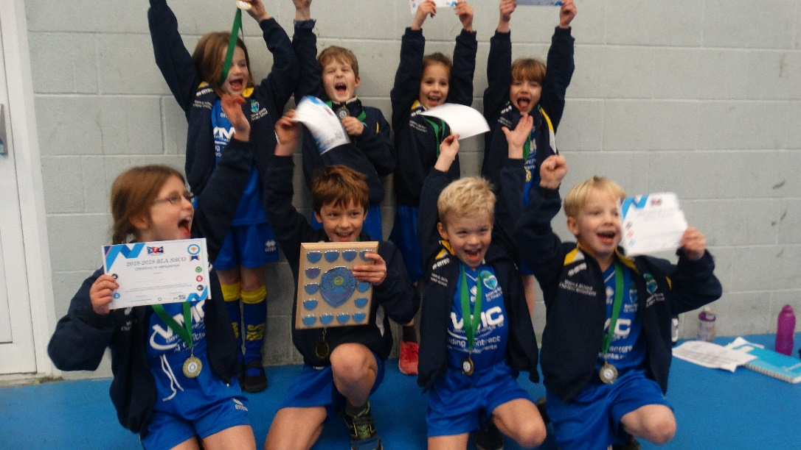

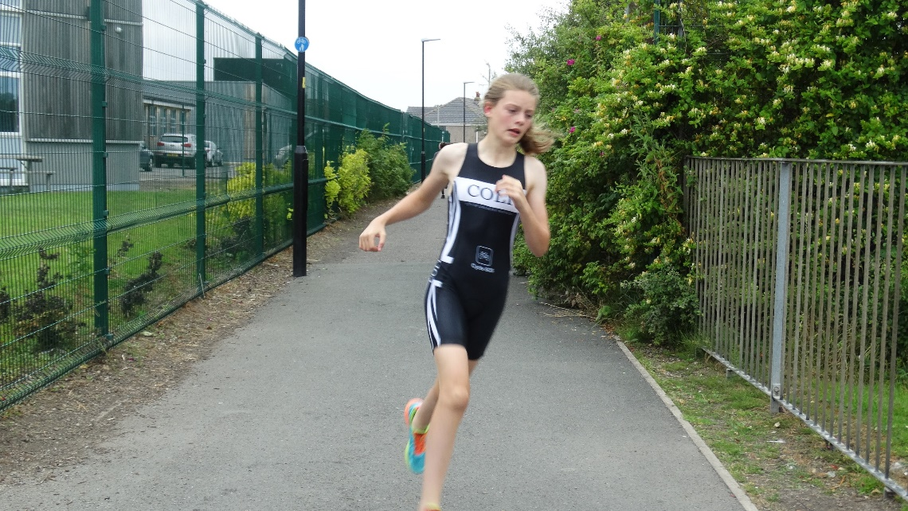

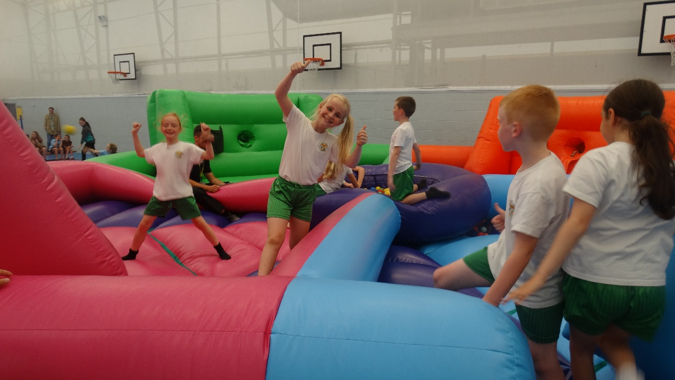

2018-2019 BLA SSCO PROGRAMME REVIEW
CONTENTS PAGE

Pages 3 & 4: 2018-2019 Bay Leadership Academy (BLA) SSCo Programme Overview
EVENT DETAILS
Pages 5, 6, 7 & 8: Year 3/4 Football Competition
Page 9: Year 3/4 Basketball Festival
Pages 10 & 11: Year 3/4 Sportshall Athletics
Pages 12 & 13: Year 1/2 Sportshall/Multi-Skills Festival
Page 14: Year 5/6 Swimming Gala
Pages 15, 16 & 17: Year 5/6 Dodgeball Tournament
Page 18: Year 3/4 & 5/6 Acro Gymnastics Events
Pages 19, 20 & 21: Year 5/6 Tag Rugby Tournament
Pages 22, 23 & 24: Year 5/6 High 5 Netball
Pages 25, 26 & 27: Year 5/6 Quicksticks Hockey Competition
Page 28: Year 5/6 Rounders
Page 29: Change 4 Life & Inflatables Festival
Pages 30 & 31: Year 5/6 Aquathlon Competition
STAFF CPD
Page 32: Nutrition & Gymnastics Equipment CPD

2018-2019 BAY LEADERSHIP ACADEMY SSCO PROGRAMME OVERVIEW

The Bay Leadership Academy (BLA) SSCo is based at BLA, utilising the fantastic facilities, including the gym, sports hall, courts and 3G astro pitch, for competitions, courses and coaching sessions. This is a intermate PE programme specifically for the schools involved, who all select its contents.

Schools enrolled: Trumacar, Morecambe Road, Slyne with Hest, Overton, Mossgate, West End, St Peters, Westgate, Sandylands, Grosvenor Park and Bolton le Sands.

Because this is a programme funded solely by the Primary schools, it will be tailored by the primary schools. Every school is different, so you would get a chance to mould the programme and tailor it to your particular needs via a questionnaire, the answers of which will determine what is in the programme. The following is what I can offer each school:

- Minimum of 2 sports competitions every term, in sports chosen by you, and targeting all age groups.

DATE | SPORT | TIME
October | Year 3/4 Football Competition | 15.45pm
November | Year 3/4 Basketball Festival | 15.45pm
November | Year 3/4 Sportshall Athletics Competition | 15.45pm
December | Year 1/2 Athletics/Multi-Skills event | 15.45pm
January | Year 5/6 Swimming Gala | 16.00pm
January | Year 5/6 Dodgeball | 16.00pm
February | Year 3/4 Acro Gymnastics event | 10.30am
February | Year 5/6 Acro Gymnastics event | 13.00pm
February | Year 5/6 Tag Rugby Competition | 15.45pm
March | Year 5/6 High 5 Netball Competition | 15.45pm
April | Year 5/6 Quicksticks Hockey Tournament | 15.30pm
June | Year 5/6 Rounder’s Tournament | 15.30pm
July | Change 4 Life/Inflatable Festival | 12.00pm
July | Year 5/6 Aquathlon | 15.45pm

Depending on funding of the programme, I would like to present every participant at every competition with a medal, certificate and the winning team with a trophy. Additionally, I can offer you any assistance you need with your own sports activities, fun days and competitions.

- Twilight Coaching Courses delivered externally or by myself. Here, I invite teachers and volunteers from your school to Heysham High at a time that suits, and I coach them how to coach various sports, who in turn practice coaching on each other with my guidance I have planned 6 weeks’ worth of progressive separate sports coaching lesson plans in sports such as, football, gymnastics, cricket, multi-skills, rugby, and netball sessions, all clear, concise and easy to follow. I have devised the programme, so the sessions come in a folder that every school gets their own copy of, so all a teacher need do is pull the folder off the shelf and deliver the sessions. I can do these for any sport you desire.

- Up to 10 FREE actual sports coaching sessions in your school. As mentioned earlier I am qualified to deliver safe, fun sports coaching sessions to any of your students, and because I have a limited timetable, I am quite flexible regards time. If there is a sport that I cannot coach, I can guarantee I have a contact that can.

- Sports Leaders Play Maker and Young Leaders course delivery – by working in conjunction with Scott Wilcox, we can deliver the Play Maker (9+ years old, 6 hours long) and Young Leaders courses (11+ years old, 6-10 hours long) to your students in your schools. These are certified courses which will start your pupils off on the leadership ladder, which in turn qualifies them to assist in playground activities.

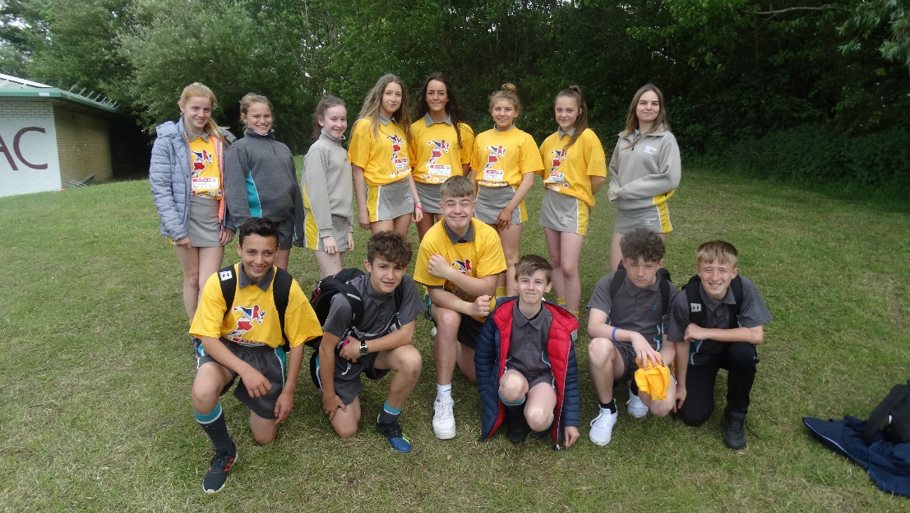

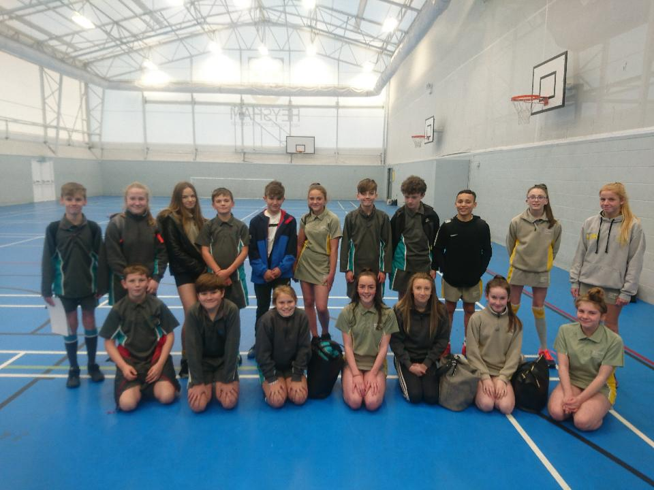

2018-2019 BLA SSCO PROGRAMME EVENT DETAILS

EVENT 1: YEAR 3/4 FOOTBALL TOURNAMENT
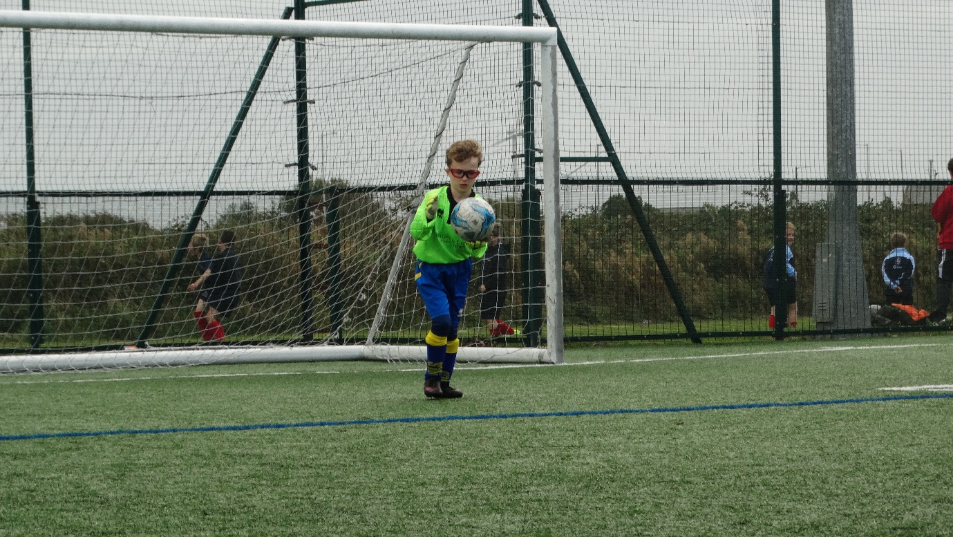

TEAMS INVOLVED:
SCHOOL
BLS Rangers
BLS Celtic
Westgate Wanderers
Westgate United
FC Grosvenor Park
Sandylands Harriers
Overton Hotspur
Slyne Argyle
Slyne Diamonds
Trumacar North End
Atletico West End
Mossgate Madrid
St Peters City
Real Grosvenor Park
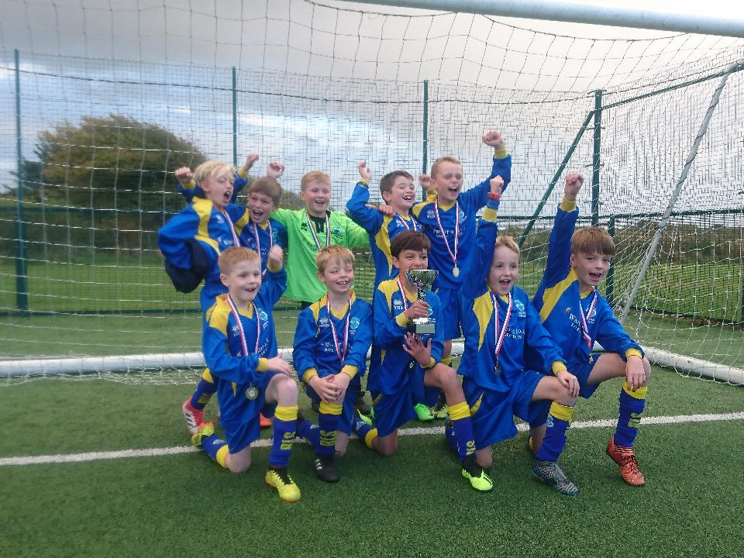

Bolton le Sands – BLA SSCO Year 3/4 Football Champions

BLA SSCO FOOTBALL TOURNAMENT FORMAT/RULES.
Date: Tuesday 2nd October 2018

Time: 15.45pm KO

Normal FA Rules

8 a side (Squads of up to 11)

Teams split in to 3 groups, each playing everyone else in their group.

GROUP STAGES
1st Place in each group play in the Championship Triangular
2nd Place in each group play in the Silver Medal Triangular
3rd Place in each group play in the Bronze Medal Triangular

TRIANGULAR STAGES
1st in Championship Triangular win’s tournament trophy and Gold Medals
1st in Silver Triangular win’s Silver medals
1st in Bronze Triangular win’s Bronze medals

All matches are 6 minutes one way

Every player MUST wear shin pads, and RUBBER STUDS/TRAINERS/ASTRO BOOTS

Max from St Peters – BLA SSCO Year 3/4 Football Star Award

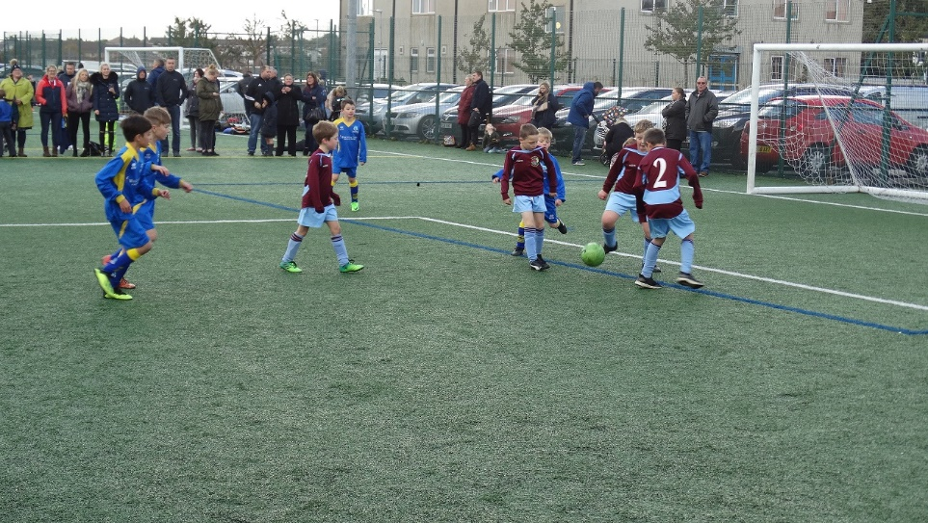

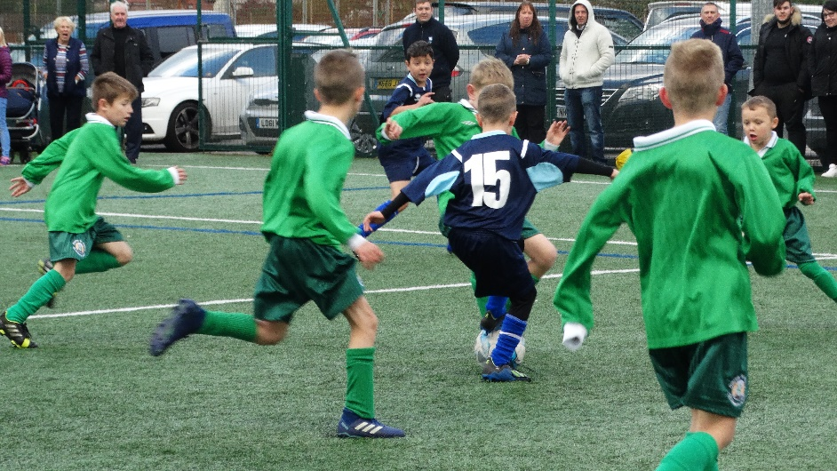

GROUP STAGES
GROUP A
Pos | Teams | GF |  |  |  | GA |  |  |  | GD | Points |  |  |  | TOTAL
1 | BLS Rangers | 3 | 1 | 3 | 2 | 0 | 0 | 0 | 0 | +9 | 3 | 3 | 3 | 3 | 12
2 | Real Grosvenor Park | 2 | 0 | 1 | 2 | 0 | 1 | 1 | 0 | +3 | 3 | 0 | 1 | 3 | 7
3 | Westgate United | 0 | 1 | 0 | 1 | 2 | 0 | 2 | 0 | +2 | 0 | 3 | 0 | 3 | 6
4 | Trumacar North End | 0 | 1 | 1 | 0 | 3 | 1 | 0 | 1 | -3 | 0 | 1 | 3 | 0 | 4
5 | Slyne Argyle | 0 | 0 | 0 | 0 | 1 | 3 | 1 | 2 | -7 | 0 | 0 | 0 | 0 | 0

GROUP B
Pos | Teams | GF |  |  |  | GA |  |  |  | GD | Points |  |  |  | TOTAL
1 | Slyne Diamonds | 5 | 2 | 1 |  | 0 | 0 | 0 |  | +8 | 3 | 3 | 3 |  | 9
2 | Sandylands Harriers | 2 | 0 | 3 |  | 0 | 2 | 0 |  | +3 | 3 | 0 | 3 |  | 6
3 | Mossgate Madrid | 0 | 4 | 0 |  | 2 | 0 | 1 |  | +1 | 0 | 3 | 0 |  | 3
4 | Westgate Wanderers | 0 | 0 | 0 |  | 5 | 4 | 3 |  | -12 | 0 | 0 | 0 |  | 0

GROUP C
Pos | Teams | GF |  |  |  | GA |  |  |  | GD | Points |  |  |  | TOTAL
1 | Overton Hotspur | 3 | 2 | 0 | 2 | 0 | 0 | 0 | 0 | +5 | 3 | 3 | 1 | 3 | 10
2 | St Peters City | 1 | 0 | 0 | 6 | 0 | 0 | 1 | 0 | +6 | 3 | 1 | 0 | 3 | 7
3 | BLS Celtic | 3 | 0 | 0 | 0 | 0 | 0 | 0 | 2 | +1 | 3 | 1 | 1 | 0 | 5
4 | Atletico West End | 0 | 0 | 0 | 3 | 1 | 0 | 2 | 0 | +2 | 0 | 1 | 0 | 3 | 4
5 | FC Grosvenor Park | 0 | 0 | 0 | 0 | 3 | 3 | 3 | 6 | -15 | 0 | 0 | 0 | 0 | 0

TRIANGULAR STAGES
CHAMPIONSHIP TRIANGULAR
POS | TEAM | GF |  | GA |  | GD | POINTS
1 | BLS RANGERS | 1 | 1 | 0 | 0 | +2 | 6
2 | SLYNE DIAMONDS | 0 | 2 | 1 | 1 | 0 | 3
3 | OVERTON HOTSPUR | 0 | 1 | 1 | 2 | -2 | 0

SILVER MEDAL TRIANGULAR
POS | TEAM | GF |  | GA |  | GD | POINTS
1 | ST PETERS CITY | 2 | 1 | 0 | 0 | +3 | 6
2 | REAL GROSVENOR PARK | 1 | 0 | 0 | 2 | -1 | 3
3 | SANDYLANDS HARRIERS | 0 | 0 | 1 | 1 | -2 | 0

BRONZE MEDAL TRIANGULAR
POS | TEAM | GF |  | GA |  | GD | POINTS
1 | MOSSGATE MADRID | 0 | 4 | 0 | 0 | +4 | 4
2 | WESTGATE UTD | 0 | 2 | 0 | 1 | +1 | 4
3 | ATLETICO WEST END | 1 | 0 | 2 | 4 | -5 | 0

FIXTURES & RESULTS
TIME | PITCH 1 | SCORE |  | PITCH 2 | SCORE |  | PITCH 3 | SCORE
GROUP STAGES
15.50pm KO | GROUP A  WESTGATE UTD v REAL GROSVENOR | 0 | 2 | GROUP B  SANDYLANDS HARRIERS v MOSSGATE MADRID | 2 | 0 | GROUP C  ATLETICO WEST END v ST PETERS CITY | 0 | 1
16.00pm KO | GROUP A  BLS RANGERS v TNE | 3 | 0 | GROUP B  WESTGATE WANDERERS v SLYNE DIAMONDS | 0 | 5 | GROUP C  FC GROSVENOR v BLS CELTIC | 3 | 0
16.10pm KO | GROUP A  SLYNE ARGYLE v WESTGATE UTD | 0 | 1 | GROUP A  REAL GROSVENOR v BLS RANGERS | 0 | 1 | GROUP C  OVERTON HOTSPUR v FC GROSVENOR | 3 | 0
16.20pm KO | GROUP A  REAL GROSVENOR v TNE | 1 | 1 | GROUP B  MOSSGATE MADRID v WESTGATE WANDERERS | 4 | 0 | GROUP C  BLS CELTIC v ATLETICO WEST END | 0 | 0
16.30pm KO | GROUP A  SLYNE ARGYLE v BLS RANGERS | 0 | 3 | GROUP C  BLS CELTIC v ST PETERS CITY | 0 | 0 | GROUP C  OVERTON HOTSPUR v ATLETICO WEST END | 1 | 1
16.40pm KO | GROUP A  BLS RANGERS v WESTGATE UTD | 2 | 0 | GROUP A  TNE v SLYNE ARGYLE | 1 | 0 | GROUP C  ATLETICO WEST END v FC GROSVENOR | 3 | 0
16.50pm KO | GROUP A  SLYNE ARGYLE v REAL GROSVENOR | 0 | 2 | GROUP B  SANDYLANDS HARRIERS v SLYNE DIAMONDS | 0 | 2 | GROUP C  ST PETERS CITY v OVERTON HOTSPUR | 0 | 0
17.00pm KO | GROUP A  WESTGATE UTD v TNE | 1 | 0 | GROUP B  WESTGATE WANDERERS v SANDYLANDS HARRIERS | 0 | 3 | GROUP C  OVERTON HOTSPUR v BLS CELTIC | 2 | 0
17.10pm KO |  |  |  | GROUP B  MOSSGATE MADRID v SLYNE DIAMONDS | 0 | 1 | GROUP C  FC GROSVENOR v ST PETERS CITY | 0 | 6
TRIANGULAR STAGES
17.20pm KO | GOLD TRIANGULAR  BLS RANGERS v SLYNE DIAMONDS | 1 | 0 | SILVER TRIANGULAR  REAL GROSVENOR v SANDYLANDS HARRIERS | 1 | 0 | BRONZE TRIANGULAR  WESTGATE UTD v MOSSGATE MADRID | 0 | 0
17.30pm KO | GOLD TRIANGULAR  BLS RANGERS v OVERTON | 1 | 0 | SILVER TRIANGULAR  REAL GROSVENOR v ST PETERS | 0 | 2 | BRONZE TRIANGULAR  WESTGATE UTD v ATLETICO WEST END | 2 | 1
17.40pm KO | GOLD TRIANGULAR  SLYNE DIAMONDS v OVERTON | 2 | 1 | SILVER TRIANGULAR  SANDYLANDS HARRIERS v ST PETERS | 0 | 1 | BRONZE TRIANGULAR  MOSSGATE MADRID v ATLETICO WEST END | 4 | 0
17.55pm | PRESENTATION

FINAL RESULTS
CHAMPIONS: BOLTON LE SANDS RANGERS
2nd Place: ST PETERS CITY (Silver Medals)
3rd Place: MOSSGATE MADRID (Bronze Medals)

EVENT 2: YEAR 3/4 BASKETBALL FESTIVAL
SCHOOLS
St Peters
Westgate
Grosvenor Park
Slyne with Hest
West End
Mossgate
Sandylands
BLS
Overton
ROTATIONS
TIME | DRIBBLING | PASSING | TACKLING/BALL PROTECTION | SHOOTING
3.55pm | St Peters/Westgate/Slyne with Hest | Grosvenor Park/West End | Mossgate/  Sandylands | BLS/Overton
4.05pm | BLS/Overton | St Peters/Westgate/  Slyne with Hest | Grosvenor Park/West End/ | Mossgate/  Sandylands
4.15pm | Mossgate/  Sandylands | BLS/Overton | St Peters/Westgate/  Slyne with Hest | Grosvenor Park/West End/
4.25pm | Grosvenor Park/West End | Mossgate/  Sandylands | BLS/Overton | St Peters/  Westgate/Slyne with Hest  PASSING
TEAMS INVOLVED:
DRIBBLING

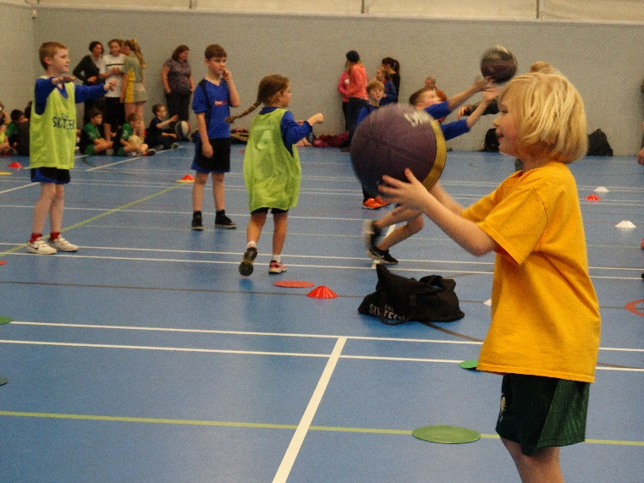
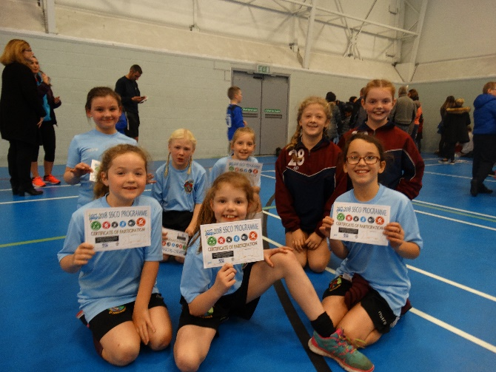

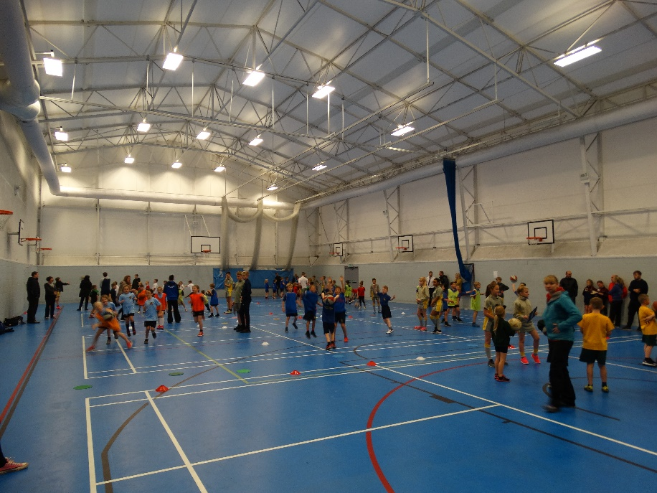
SHOOTING

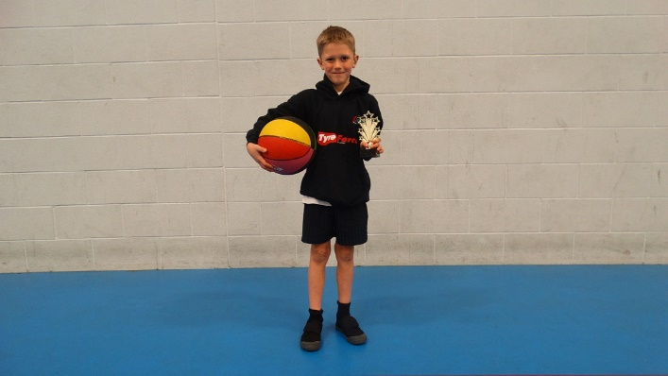

Student from Mossgate – BLA SSCO Basketball Star Award

MATCHES

EVENT 3: YEAR 3/4 SPORTSHALL ATHLETICS COMPETITION
TEAMS INVOLVED:
SCHOOL
BLS
Mossgate
Westgate
Overton
Slyne with hest
Sandylands
Trumacar
Grosvenor Park
St Peters
West End
FIELD EVENTS
Girls Long Jump | The athlete must stand on the mat with both feet behind the take-off datum line
Boys Long Jump | The athlete must stand on the mat with both feet behind the take-off datum line
Girls Speed Bounce | Speed Bounce is a two-footed jump in which an athlete must take off and land on both feet – the athlete’s feet should leave the  mat simultaneously and land on the mat simultaneously.
Boys Speed Bounce | Speed Bounce is a two-footed jump in which an athlete must take off and land on both feet – the athlete’s feet should leave the  mat simultaneously and land on the mat simultaneously.
Girls Chest Push | The athlete holds the ball against their chest and pushes with both hands.
Boys Chest Push | The athlete holds the ball against their chest and pushes with both hands.
Girls Javelin | The javelin is thrown from a standing position with both feet behind the throwing line and in contact with the floor.
Boys Javelin | The javelin is thrown from a standing position with both feet behind the throwing line and in contact with the floor.
TRACK EVENTS
2X 1 Girls Relay | 2 Athletes. Each team member completes one lap each
2X1 Boys Relay | 2 Athletes. Each team member completes one lap each
2x2 Girls Relay | 2 Athletes. Each team member completes two laps each. The athlete’s two laps are completed consecutively
2x2 Boys Relay | 2 Athletes. Each team member completes two laps each. The athlete’s two laps are completed consecutively
2x1 Girls Hurdles | 2 Athletes. Each team member completes one lap each
2x1 Boys Hurdles | 2 Athletes. Each team member completes one lap each
4x1 Girls Obstacle Race | Each member of the girl’s team completes 1 lap of various skills.
4x1 Boys Obstacle Race | Each member of the boy’s team completes 1 lap of various skills.
4x1 Girls Relay Sprints | Each member of the girl’s team completes 1 sprint lap
4x1 Boys Relay Sprints | Each member of the boy’s team completes 1 sprint lap.
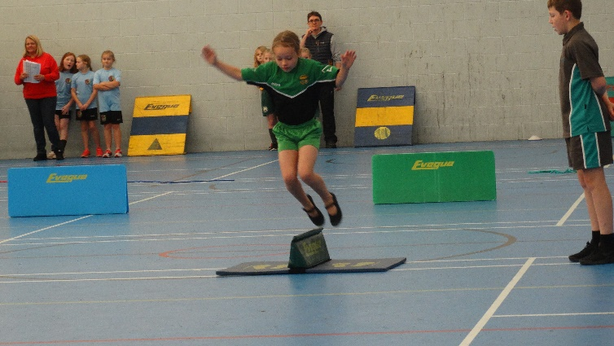
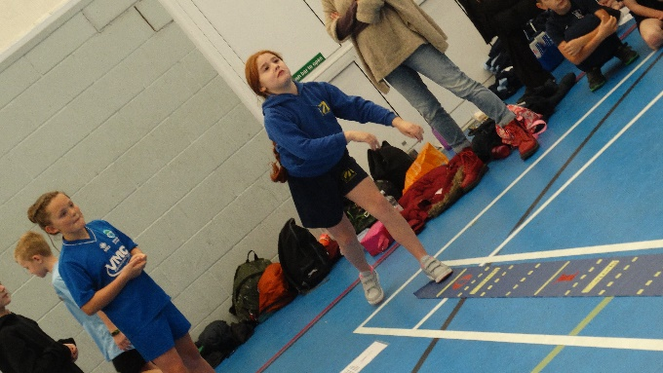

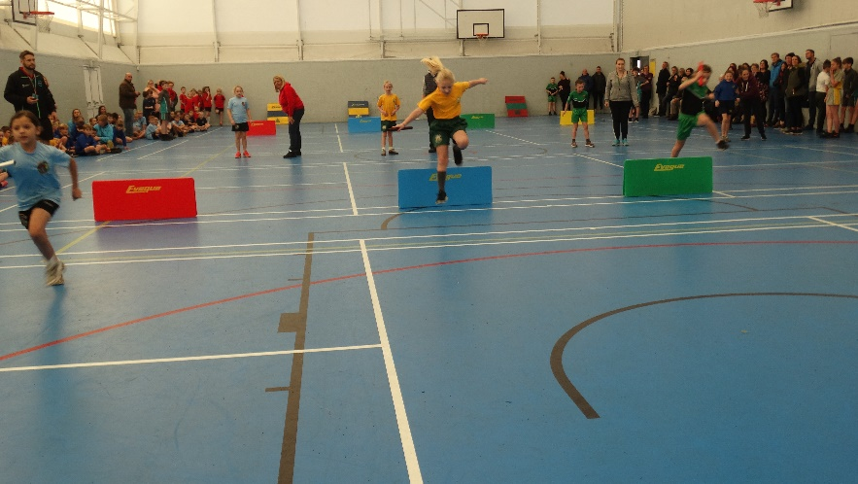
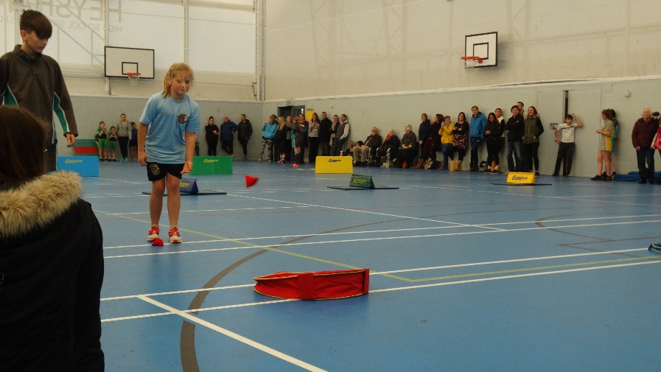

LEAGUE TABLE:
POSITION | SCHOOL | POINTS
1 | BOLTON LE SANDS | 518
2 | OVERTON ST HELENS | 476
3 | GROSVENOR PARK | 414
4 | ST PETERS | 412
5 | WESTGATE | 378
6 | SLYNE WITH HEST | 352
7 | MOSSGATE | 346
8 | TRUMACAR | 342
9 | SANDYLANDS | 296
10 | WEST END | 292
FINAL RESULTS
CHAMPIONS: BOLTON LE SANDS
2nd Place: OVERTON ST HELENS (Silver Medals)
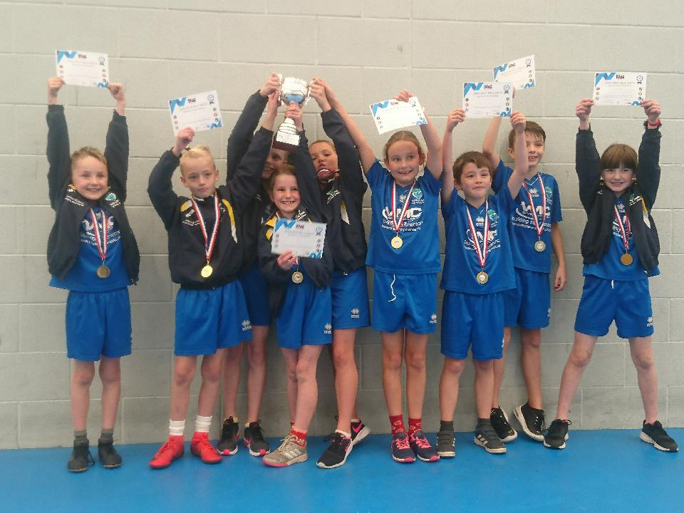
3rd Place: GROSVENOR PARK (Bronze Medals)
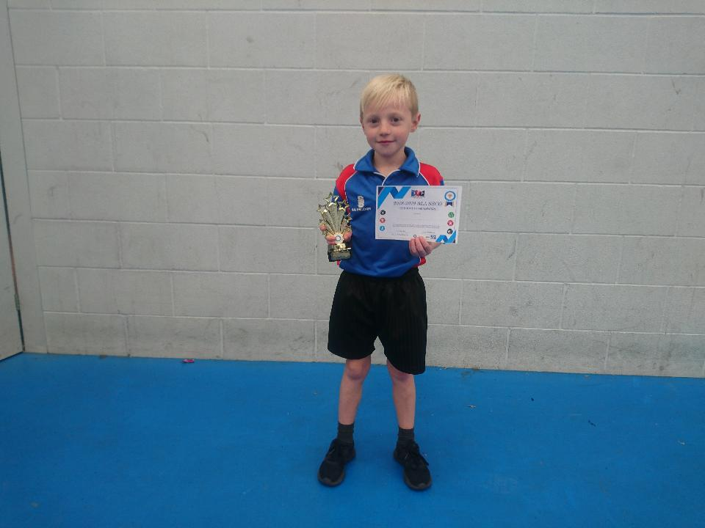

Max from St Peters – BLA SSCO Year 3/4 Sportshall Athletics Star Award

Bolton le Sands – BLA SSCO Year 3/4 Sportshall Athletics Champions

EVENT 4: YEAR 1/2 MULTI-SKILLS & ATHLETICS FESTIVAL
SCHOOL
BLS
West End
Mossgate
Westgate
Overton
Slyne with hest
St Peters
Trumacar
Sandylands
TEAMS INVOLVED:
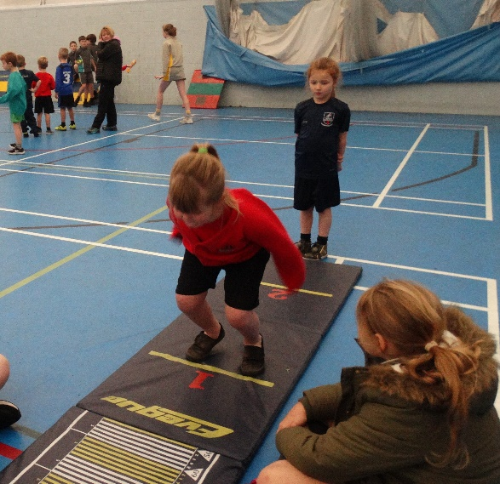

EVENT LIST:
SPEED BOUNCE
JAVELIN
LONG JUMP
TARGET THROW
2X1 Girls Relay HEAT 1
2X1 Girls Relay HEAT 2
2X1 Boys Relay HEAT 1
2X1 Boys Relay HEAT 2
2x2 Girls Relay HEAT 1
2x2 Girls Relay HEAT 2
2x2 Boys Relay HEAT 1
2x2 Boys Relay HEAT 2
4x1 Girls Egg & Spoon HEAT 1
4x1 Girls Egg & Spoon HEAT 2
4x1 Boys Egg & Spoon HEAT 1
4x1 Boys Egg & Spoon HEAT 2
4x1 Girls Obstacle Relay HEAT 1
4x1 Girls Obstacle Relay HEAT 2
4x1 Boys Obstacle Relay HEAT 1
4x1 Boys Obstacle Relay HEAT 2
4x1 Girls Relay HEAT 1
4x1 Girls Relay HEAT 2
4x1 Boys Relay HEAT 1
4x1 Boys Relay HEAT 2
8x1 Basketball Dribble HEAT 1
8x1 Basketball Dribble HEAT 2
8x1 Football Dribble HEAT 1
8x1 Football Dribble HEAT 2

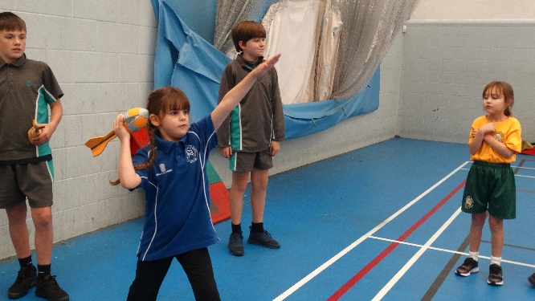

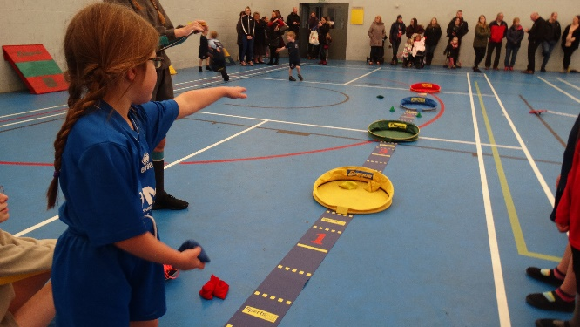

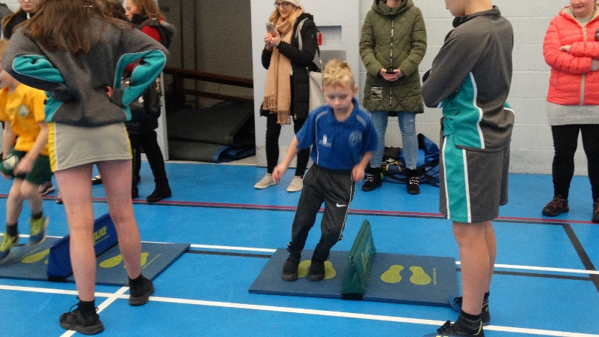
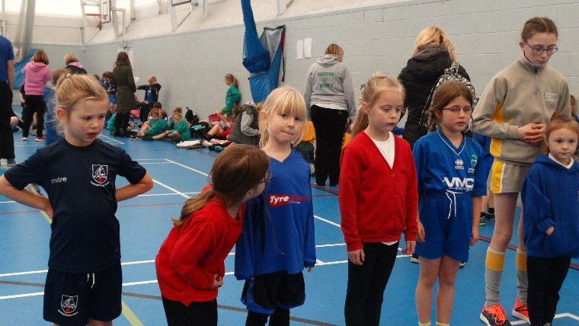

LEAGUE TABLE:
POSITION | SCHOOL | POINTS
1 | BOLTON LE SANDS | 476
2 | ST PETERS | 460
3 | GROSVENOR PARK | 454
4 | OVERTON ST HELENS | 448
5 | SANDYLANDS | 408
6 | WEST END | 372
7 | MOSSGATE | 354
8 | TRUMACAR | 316
9 | WESTGATE | 308
FINAL RESULTS
CHAMPIONS: BOLTON LE SANDS
2nd Place: ST PETERS (Silver Medals)
3rd Place: GROSVENOR PARK (Bronze Medals)
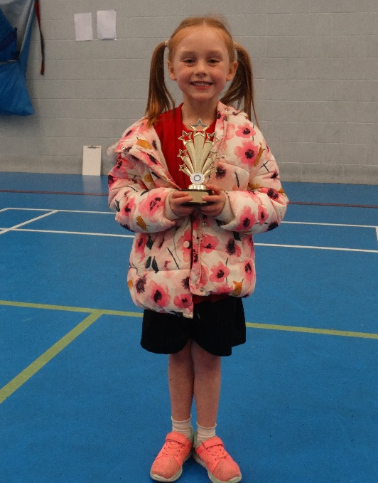

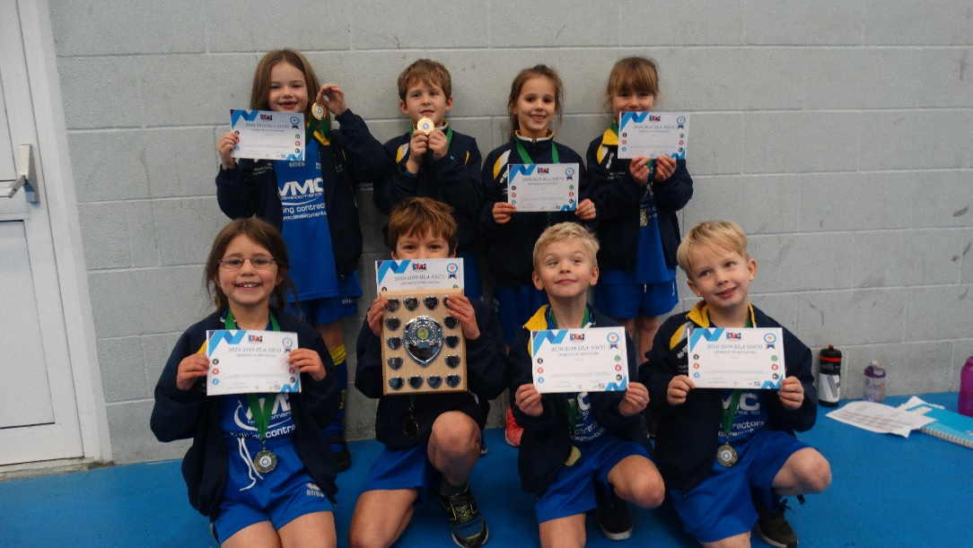

Francesca from Trumacar – BLA SSCO Year 1/2 Multi-Skills & Athletics Star Award

Bolton le Sands – BLA SSCO Year 1/2 Multi-Skills & Athletics Champions

EVENT 5: YEAR 5/6 SWIMMING GALA
TEAMS INVOLVED:
SCHOOL
BLS
SLYNE WITH HEST
WESTGATE
GROSVENOR PARK
TRUMACAR

EVENTS
Girl– FRONT CRAWL
Boy - FRONT CRAWL
Girl - BACKSTROKE
Boy - BACKSTROKE
Girl – BREAST STROKE
Boy - BREAST STROKE
Girl – FREESTYLE
Boy - FREESTYLE
GIRLS FRONT CRAWL RELAY
BOYS FRONT CRAWL RELAY
GIRLS MEDELY RELAY – CRAWL/BACK STROKE/BREAST STROKE/FREESTYLE/FREESTYLE
BOYS MEDELY RELAY - CRAWL/BACK STROKE/BREAST STROKE/FREESTYLE/FREESTYLE
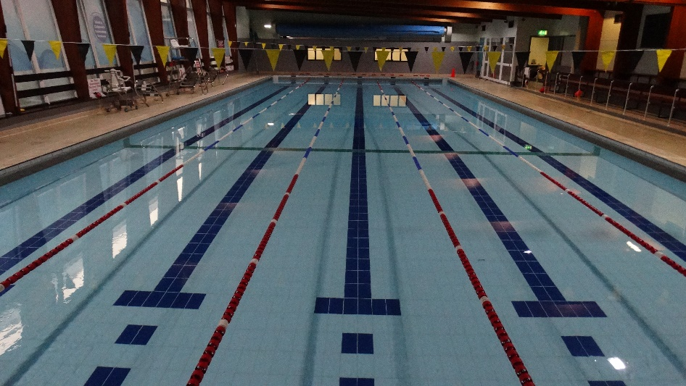

POSITION | SCHOOL | POINTS
1 | SLYNE WITH HEST | 545
2 | GROSVENOR PARK | 505
3 | BOLTON LE SANDS | 475
4 | TRUMACAR | 380
5 | WESTGATE | 190

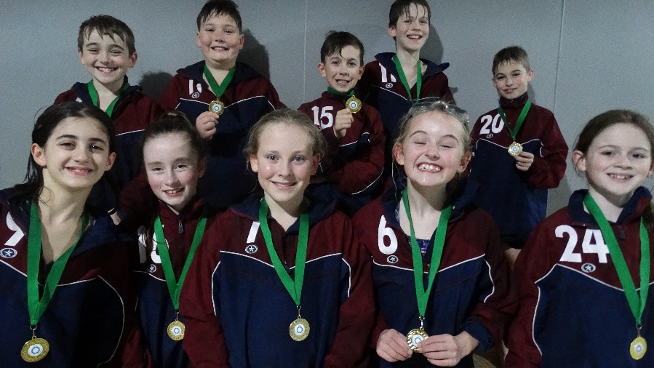
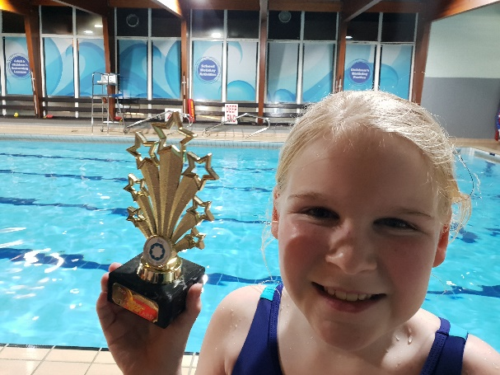

Student from Westgate – BLA SSCO Year 5/6 Swimming Gala Star Award

Slyne with Hest – BLA SSCO Year 5/6 Swimming Gala Champions

EVENTS 6: YEAR 5/6 DODGEBALL TOURNAMENT
NUM | SCHOOL
1 | Westgate Giants
2 | Westgate Blaze
3 | BLS Mavericks
4 | BLS Wasps
5 | BLS Thunder
6 | Slyne Steelers
7 | Slyne Devils
8 | Trumacar Hurricanes
9 | Trumacar Flames
10 | St Peters Blizzard
11 | Mossgate Panthers
12 | Mossgate Bears (Boys Only)
13 | West End Wizards
14 | Grosvenor Park Storm
15 | Grosvenor Park Sirens
16 | St Peters Dragons
17 | St Peters Wolves
18 | Slyne Stars
19 | West End Lightning
TEAMS INVOLVED:
BLA SSCO YEAR 5/6 DODGEBALL COMPETITION RULES.
Date: Thursday 7th February

Time: 3.45pm KO

6 a side (3 girls and 3 boys on court)

Teams split in to 4 groups, each playing everyone else in their group.

COMPETITION FORMAT

- Top Team goes through to the knockout rounds
- Semi Final winners go through to the final (Gold/Silver Medals)
- Semi Final losers play in 3rd/4th Place Play off (Bronze Medals)

RULES

- Matches are best of 3 (will play all 3 games), each game is 2 minutes long.
- 2 points for win, 1 point for draw, 0 points for loss
- Player out if a ball hits below the head, directly thrown from the opposition or their throw gets caught by the opposition. Head shots do not count whether they are facing away or not.
- Players can come back in if their team catch the ball, but in order they were out.
- Games are won by eliminating all the opposition players or by having more players on your team at the end of the 2 minutes. The game will end in a draw if the same number of players are on both sides after the 2 minutes.

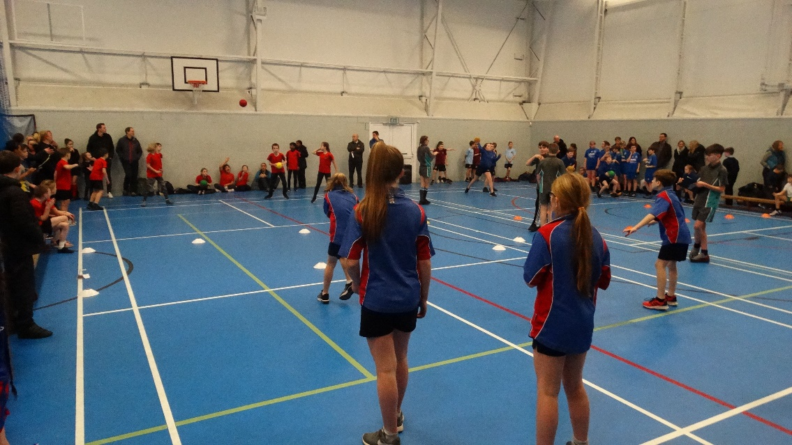

FIXTURES & RESULTS:
FIXTURES/RESULTS
TIME | COURT 1 | RES |  | COURT 2 | RES |  | COURT 3 | RES |  | COURT 4 | RES
3.50pm | GROUP A  BLS THUNDER v GROSVENOR PARK STORM | 4 | 2 | GROUP B  BLS WASPS v WEST END WIZARDS | 1 | 5 | GROUP C  WESTGATE BLAZE v SP WOLVES | 3 | 3 | GROUP D  MOSSGATE BEARS v BLS MAVERICKS | 3 | 3
 | GROUP A  MOSSGATE PANTHERS v SLYNE STARS | 4 | 2 | GROUP B  TRUMACAR HURRICANES v SLYNE DEVILS | 2 | 4 | GROUP C  WEST END LIGHTNING v TRUMACAR FLAMES | 3 | 3 | GROUP D  SLYNE STEELERS v SP BLIZZARD | 2 | 4
 | GROUP A  WESTGATE GIANTS v MOSSGATE PANTHERS | 4 | 2 | GROUP B  SP DRAGONS v BLS WASPS | 3 | 3 | GROUP C  GROSVENOR PARK SIRENS v WEST END LIGHTNING | 4 | 2 | GROUP D  SP BLIZZARD v MOSSGATE BEARS | 4 | 2
 | GROUP A  SLYNE STARS v BLS THUNDER | 2 | 4 | GROUP B  WEST END WIZARDS v SLYNE DEVILS | 5 | 1 | GROUP C  TRUMACAR FLAMES v WESTGATE BLAZE | 3 | 3 | GROUP D  SLYNE STEELERS v BLS MAVERICKS | 4 | 2
 | GROUP A  SLYNE STARS v GROSVENOR PARK STORM | 4 | 2 | GROUP B  WEST END WIZARDS v TRUMACAR HURRICANES | 3 | 3 | GROUP C  TRUMACAR FLAMES v SP WOLVES | 2 | 4 | GROUP D  MOSSGATE BEARS v SLYNE STEELERS | 2 | 4
 | GROUP A  WESTGATE GIANTS v BLS THUNDER | 4 | 2 | GROUP B  SP DRAGONS v SLYNE DEVILS | 5 | 1 | GROUP C  GROSVENOR PARK SIRENS v WESTGATE BLAZE | 2 | 4 | GROUP D  SP BLIZZARD v BLS MAVERICKS | 6 | 0
 | GROUP A  BLS THUNDER v MOSSGATE PANTHERS | 4 | 2 | GROUP B  SLYNE DEVILS v BLS WASPS | 3 | 3 | GROUP C  WESTGATE BLAZE v WEST END LIGHTNING | 1 | 5 | GROUP D  MOSSGATE BEARS v BLS MAVERICKS | 4 | 2
 | GROUP A  GROSVENOR PARK STORM v WESTGATE GIANTS | 0 | 6 | GROUP B  TRUMACAR HURRICANES v SP DRAGONS | 3 | 3 | GROUP C  SP WOLVES v GROSVENOR PARK SIRENS | 0 | 6 | GROUP D  SLYNE STEELERS v SP BLIZZARD | 0 | 6
 | GROUP A  WESTGATE GIANTS v SLYNE STARS | 6 | 0 | GROUP B  SP DRAGONS v WEST END WIZARDS | 3 | 3 | GROUP C  GROSVENOR PARK SIRENS v TRUMACAR FLAMES | 2 | 4 | GROUP D  SP BLIZZARD v MOSSGATE BEARS | 4 | 2
 | GROUP A  MOSSGATE PANTHERS v GROSVENOR PARK STORM | 3 | 3 | GROUP B  BLS WASPS v TRUMACAR HURRICANES | 2 | 4 | GROUP C  WEST END LIGHTNING v SP WOLVES | 5 | 1 | GROUP D  SLYNE STEELERS v BLS MAVERICKS | 6 | 0
 | SEMI-FINAL 1  WESTGATE GIANTS v WEST END WIZARDS | 6 | 0 |  |  |  | SEMI-FINAL 1  WEST END LIGHTNING v SP BLIZZARD | 2 | 4
 | FINAL  SP BLIZZARD v WESTGATE GIANTS | 5 | 1 |  |  |  | 3RD/4TH PLAYOFF  WEST END WIZARDS v WEST END LIGHTNING | 5 | 1
6.00pm | PRESENTATION
FINAL RESULTS
CHAMPIONS: ST PETERS BLIZZARD
2nd Place: WESTGATE GIANTS (Silver Medals)
3rd Place: WEST END WIZARDS (Bronze Medals)
4TH Place: WEST END LIGHTNING
GROUP A
Pos | Teams | Points |  |  |  | TOTAL
1 | Westgate Giants | 4 | 4 | 6 | 6 | 20
2 | BLS Thunder | 4 | 4 | 2 | 4 | 14
3 | Mossgate Panthers | 4 | 2 | 2 | 3 | 11
4 | Slyne Stars | 2 | 2 | 4 | 0 | 8
5 | Grosvenor Park Storm | 2 | 2 | 0 | 3 | 7
GROUP B
Pos | Teams | Points |  |  |  | TOTAL
1 | West End Wizards | 5 | 5 | 3 | 3 | 16
2 | St Peters Dragons | 3 | 5 | 3 | 3 | 14
3 | Trumacar Hurricanes | 2 | 3 | 3 | 4 | 12
Joint  4 | Slyne Devils | 4 | 1 | 1 | 3 | 9
 | BLS Wasps | 1 | 3 | 3 | 2 | 9
GROUP STAGES:

*Mossgate are entering an all-boys team, who can compete but will not go through

GROUP C
Pos | Teams | Points |  |  |  | TOTAL
1 | West End Lightning | 3 | 2 | 5 | 5 | 15
2 | Grosvenor Park Sirens | 4 | 2 | 6 | 2 | 14
3 | Trumacar Flames | 3 | 3 | 2 | 4 | 12
4 | Westgate Blaze | 3 | 3 | 4 | 1 | 11
5 | St Peters Wolves | 3 | 4 | 0 | 1 | 8

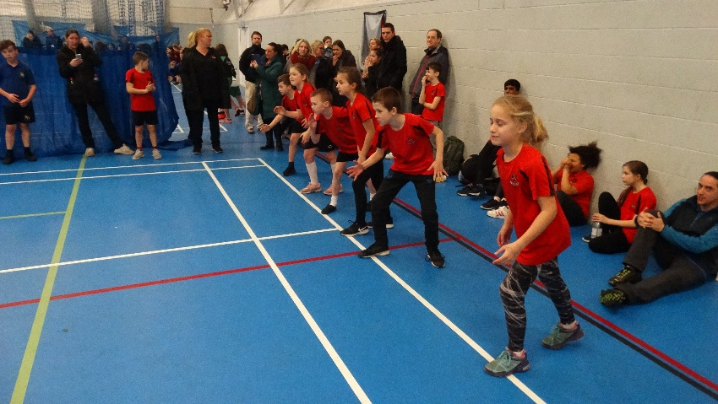
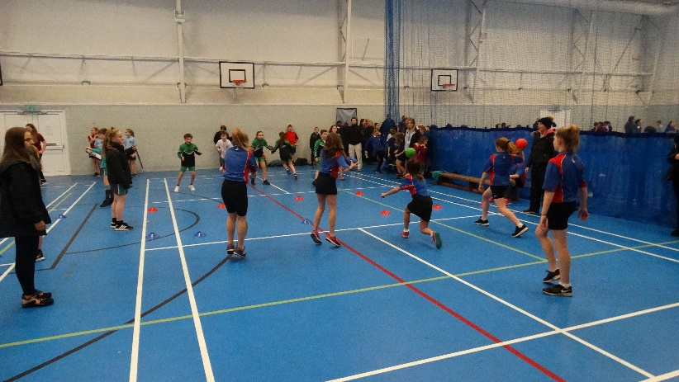

GROUP D
Pos | Teams | Points |  |  |  |  | TOTAL
1 | St Peters Blizzard | 4 | 4 | 6 | 6 | 4 | 24
2 | Slyne Steelers | 2 | 4 | 4 | 0 | 6 | 16
3 | *Mossgate Bears (Boys) | 3 | 2 | 2 | 4 | 2 | 13
4 | BLS Mavericks | 3 | 2 | 0 | 2 | 0 | 7

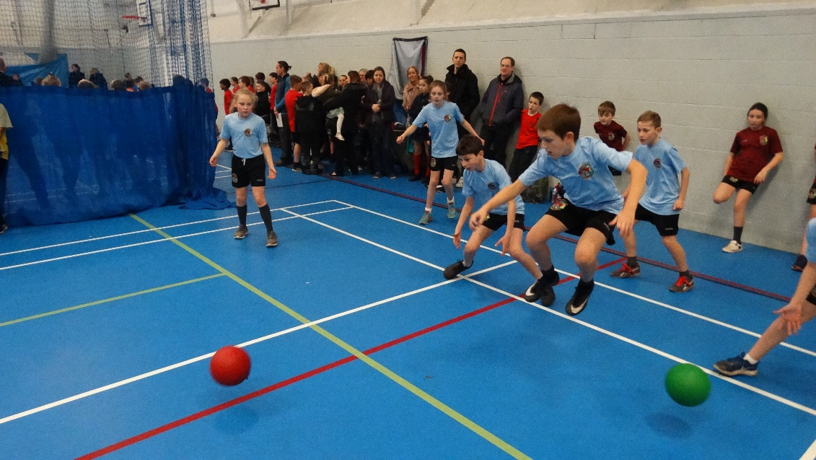

EVENTS 7 & 8: YEAR 3/4 & 5/6 GYMNASTICS FESTIVALS
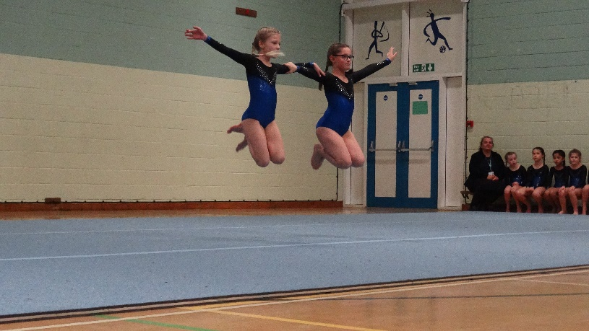
TEAMS INVOLVED:
NUMBER | YEAR 3/4 TEAMS | YEAR 5/6 TEAMS
1 | Overton St Helens | Sandylands
2 | Westgate Blue | Grosvenor Park
3 | Grosvenor Park | Slyne Purple
4 | Westgate White | Slyne Blue
5 | St Peters | Westgate Yellow
6 |  | Westgate White
7 |  | St Peters
8 |  | Slyne Silver
9 |  | Overton

YEAR 3/4 TEAM RESULTS
1st Team | WESTGATE WHITE | 24.35
2nd Team | OVERTON | 23.6
3rd Team | ST PETERS | 23.4
4th Team | GROSVENOR PARK | 21.4
5th Team | WESTGATE BLUE | 21.25

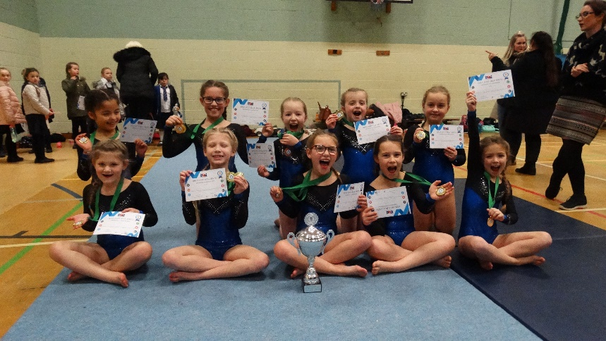
YEAR 3/4 PAIRS RESULTS
1st Pair | KIERA & FAITH (WEST) | 8.7
2nd Pair | LEAH & MIA (OVER) | 8.35
3rd Pair | HOLLY & AVA (WEST) | 8.25

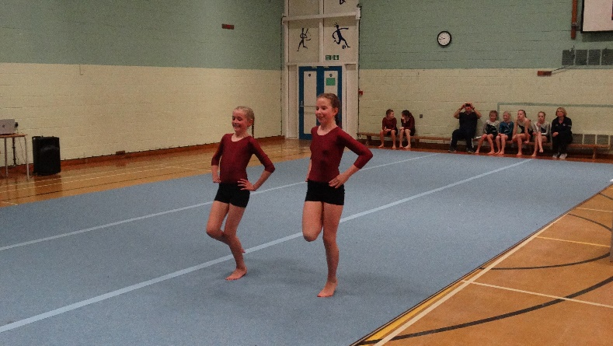
Westgate – BLA SSCO Year 3/4 Gymnastics Champions

YEAR 5/6 TEAM RESULTS
1st Team | ST PETERS | 26.55
2nd Team | SLYNE SILVER | 25.6
3rd Team | WESTGATE WHITE | 24.5
4th Team | OVERTON | 24.35
5th Team | WESTGATE YELLOW | 24.2
6th Team | SLYNE BLUE | 23.15
7th Team | SLYNE PURPLE | 23.1
8th Team | GROSVENOR PARK | 22.9
9th Team | WESTGATE BLUE | 22.8

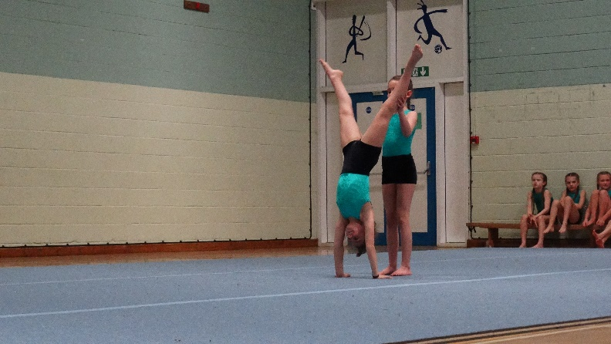

YEAR 5/6 PAIRS RESULTS
1st Pair | FARREN & ANYA (St P) | 8.9
2nd Pair | MIA & LAYLA (St P) | 8.85
 | EVE & CHLOE (Slyne)
3rd Pair | MILLIE & OLIVER (St P) | 8.6

EVENT 9: YEAR 5/6 TAG RUGBY TOURNAMENT
NUM | TEAMS
1 | Grosvenor Park Falcons
2 | Sandylands Storm
3 | BLS Warriors
4 | BLS Dragons
5 | BLS Bandits
6 | Trumacar Titans
7 | Trumacar Springboks
8 | Sandylands Atoms
9 | Overton Eagles
10 | Morecambe Road Majestics
11 | Grosvenor Park Saints
12 | St Peters Tigers
13 | Slyne with Hest Giants
14 | Slyne with Hest Red Devils
15 | Slyne with Hest Vikings
16 | Westgate Wildcats
17 | Westgate Wonders
18 | Mossgate Hawks
TEAMS INVOLVED:
BLA SSCO YEAR 5/6 TAG RUGBY TOURNMENT RULES.
- Date: Tuesday 26th February 2019
- Venue: Bay Leadership Academy (Astro Pitch)
- 12.00pm start time, finish time is approx. 3.00pm

Competition Rules

- Squads selected from years 5 and 6
- 7 a side, mixed squads of 11, minimum 3 of one gender on the pitch at one time
- 5 minutes ONE WAY
- GROUP STAGE SCORING - 3 POINTS FOR A WIN, 1 FOR A DRAW 0 FOR LOSS

Competition Format

- 1st IN EACH GROUP GO THROUGH TO THE CHAMPIONSHIP TRIANGULAR
- 2nd IN EACH GROUP GO FORWARD TO THE BRONZE MEDAL TRIANGULAR
- THE OTHER TEAMS ARE OUT (there is a spare pitch for friendly games if schools want them)

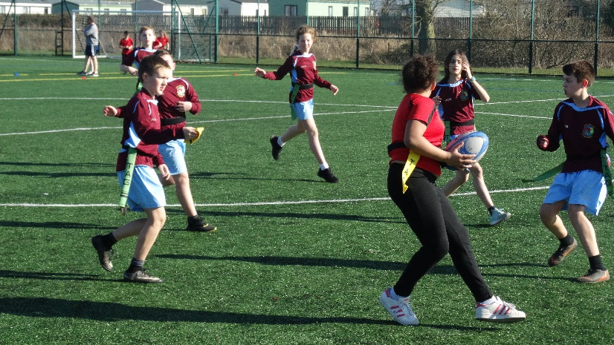

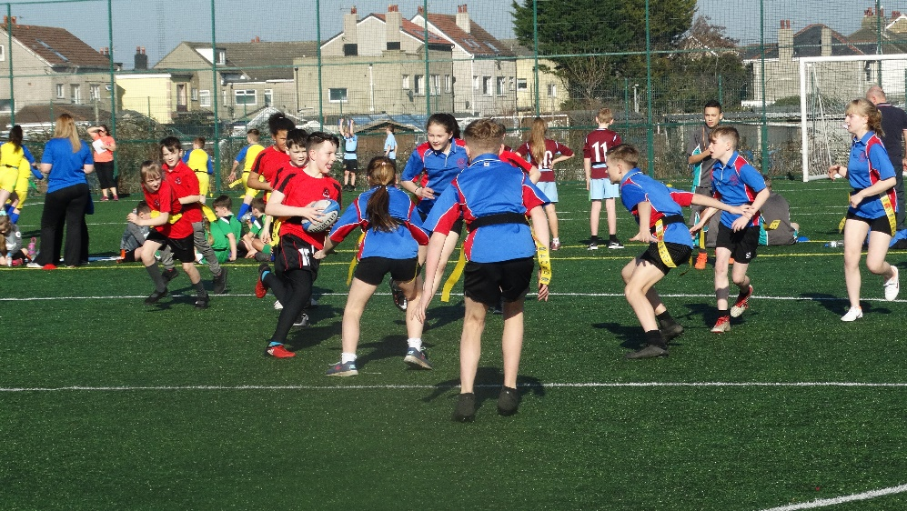

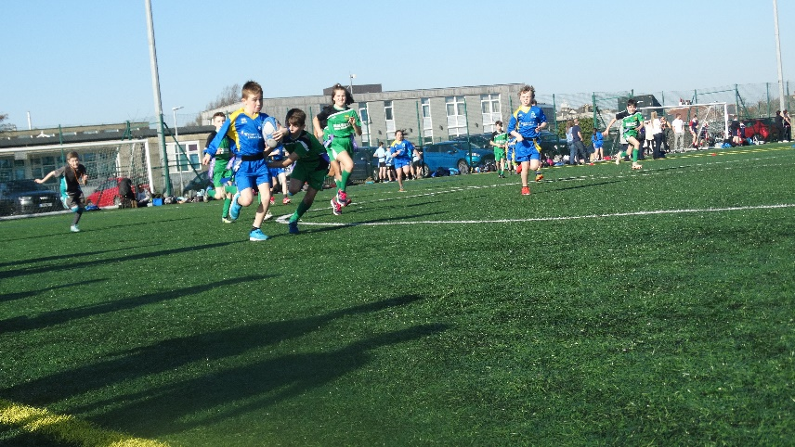

FIXTURES & RESULTS:
TIME | PITCH 1 | SCORE |  | PITCH 2 | SCORE |  | PITCH 3 | SCORE
12.00pm | GROUP A  WESTGATE WILDCATS v GROSVENOR PARK FALCONS | 1 | 3 | GROUP A  SANDYLANDS ATOMSv SLYNE GIANTS | 1 | 1 | GROUP A  BLS WARRIORS v MORECAMBE ROAD MAJESTICS | 3 | 0
 | GROUP B  BLS DRAGONS v ST PETERS TIGERS | 1 | 2 | GROUP B  SANDYLANDS STORM v SLYNE VIKINGS | 0 | 3 | GROUP B  TRUMACAR SPRINGBOKS v WESTGATE WONDERS | 2 | 3
 | GROUP C  SLYNE RED DEVILS v GROSVENOR PARK SAINTS | 4 | 0 | GROUP C  OVERTON EAGLES v MOSSGATE HAWKS | 3 | 2 | GROUP C  TRUMACAR TITANS v BLS BANDITS | 5 | 0
 | GROUP A  SLYNE GIANTS v WESTGATE WILDCATS | 2 | 4 | GROUP A  MORECAMBE ROAD MAJESTICS v GROSVENOR PARK FALCONS | 0 | 5 | GROUP A  BLS WARRIORS v SANDYLANDS ATOMS | 4 | 3
 | GROUP B  SLYNE VIKINGS v BLS DRAGONS | 4 | 3 | GROUP B  WESTGATE WONDERS v ST PETERS TIGERS | 2 | 3 | GROUP B  TRUMACAR SPRINGBOKS v SANDYLANDS STORM | 4 | 0
 | GROUP C  MOSSGATE HAWKS v SLYNE RED DEVILS | 0 | 4 | GROUP C  BLS BANDITS v GROSVENOR PARK SAINTS | 1 | 4 | GROUP C  TRUMACAR TITANS v OVERTON EAGLES | 3 | 3
 | GROUP A  WESTGATE WILDCATS v MORECAMBE ROAD MAJESTICS | 3 | 0 | GROUP A  SLYNE GIANTS v BLS WARRIORS | 0 | 2 | GROUP A  GROSVENOR PARK FALCONS v SANDYLANDS ATOMS | 3 | 2
 | GROUP B  BLS DRAGONS v WESGATE WONDERS | 1 | 3 | GROUP B  SYLNE VIKINGS v TRUMACAR SPRINGBOKS | 1 | 2 | GROUP B  ST PETERS TIGERS v SANDYLANDS STORM | 2 | 1
 | GROUP C  SLYNE RED DEVILS v BLS BANDITS | 4 | 3 | GROUP C  MOSSGATE HAWKS v TRUMACAR TITANS | 2 | 2 | GROUP C  GROSVENOR PARK SAINTS v OVERTON EAGLES | 2 | 5
 | GROUP A  BLS WARRIORS v WESTGATE WILDCATS | 1 | 2 | GROUP A  SANDYLANDS ATOMS v MORECAMBE ROAD MAJESTICS | 4 | 0 | GROUP A  GROSVENOR PARK FALCONS v SLYNE GIANTS | 6 | 1
 | GROUP B  TRUMACAR SPRINGBOKS v BLS DRAGONS | 0 | 3 | GROUP B  SANDYLANDS STORM v WESTGATE WONDERS | 2 | 1 | GROUP B  ST PETERS TIGERS v SLYNE VIKINGS | 4 | 0
 | GROUP C  TRUMACAR TITANS v SLYNE RED DEVILS | 4 | 1 | GROUP C  OVERTON EAGLES v BLS BANDITS | 3 | 3 | GROUP C  GROSVENOR PARK SAINTS v MOSSGATE HAWKS | 0 | 0
 | GROUP A  WESTGATE WILDCATS v SANDYLANDS ATOMS | 5 | 3 | GROUP A  BLS WARRIORS v GROSVENOR PARK FALCONS | 4 | 3 | GROUP A  MORECAMBE ROAD MAJESTICS v SLYNE GIANTS | 2 | 2
 | GROUP B  BLS DRAGONS v SANDYLANDS STORM | 4 | 1 | GROUP B  TRUMACAR SPRINGBOKS v ST PETERS TIGERS | 1 | 2 | GROUP B  WESTGATE WONDERS v SLYNE VIKINGS | 2 | 2
 | GROUP C  SLYNE RED DEVILS v OVERTON EAGLES | 2 | 4 | GROUP C  TRUMACAR TITANS v GROSVENOR PARK SAINTS | 3 | 0 | GROUP C  BLS BANDITS v MOSSGATE HAWKS | 2 | 3
 | CHAMPIONSHIP TRIANGULAR  ST PETERS TIGERS v GROSVENOR PARK FALCONS | 2 | 1 |  |  |  | BRONZE TRIANGULAR  WESTGATE WILDCATS v WESTGATE WONDERS | 4 | 2
 | CHAMPIONSHIP TRIANGULAR  GROSVENOR PARK FALCONS v TRUMACAR TITANS | 3 | 2 |  |  |  | BRONZE TRIANGULAR  WESTGATE WILDCATS v OVERTON EAGLES | 2 | 4
 | CHAMPIONSHIP TRIANGULAR  ST PETERS v TRUMACAR TITANS | 4 | 1 |  |  |  | BRONZE TRIANGULAR  WESTGATE WONDERS v OVERTON EAGLES | 2 | 4
FINAL RESULTS
CHAMPIONS: ST PETERS TIGERS
2nd Place: GROSVENOR PARK FALCONS (Silver Medals)
3rd Place: OVERTON EAGLES (Bronze Medals)

GROUP STAGES

GROUP A
Pos | TEAMS | TRIES FOR |  |  |  |  | TRIES AGAINST |  |  |  |  | TD | POINTS |  |  |  |  | TOTAL
1 | Grosvenor Park Falcons | 3 | 5 | 3 | 6 | 3 | 1 | 0 | 2 | 1 | 4 | +12 | 3 | 3 | 3 | 3 | 0 | 12
2 | Westgate Wildcats | 1 | 4 | 3 | 2 | 5 | 3 | 2 | 0 | 1 | 3 | +6 | 0 | 3 | 3 | 3 | 3 | 12
3 | BLS Warriors | 3 | 4 | 2 | 1 | 4 | 0 | 3 | 0 | 2 | 3 | +6 | 3 | 3 | 3 | 0 | 3 | 12
4 | Sandylands Atoms | 1 | 3 | 2 | 4 | 3 | 1 | 4 | 3 | 0 | 5 | +1 | 1 | 0 | 0 | 3 | 0 | 4
5 | Slyne with Hest Giants | 1 | 2 | 0 | 1 | 2 | 1 | 4 | 2 | 6 | 2 | -9 | 1 | 0 | 0 | 0 | 1 | 2
6 | Morecambe Road Majestics | 0 | 0 | 0 | 0 | 2 | 3 | 5 | 3 | 4 | 2 | -15 | 0 | 0 | 0 | 0 | 1 | 1

GROUP B
Pos | TEAMS | TRIES FOR |  |  |  |  | TRIES AGAINST |  |  |  |  | TD | POINTS |  |  |  |  | TOTAL
1 | St Peters Tigers | 2 | 3 | 2 | 4 | 2 | 1 | 2 | 1 | 0 | 1 | +8 | 3 | 3 | 3 | 3 | 3 | 15
2 | Westgate Wonders | 3 | 2 | 3 | 1 | 2 | 2 | 3 | 1 | 2 | 2 | +1 | 3 | 0 | 3 | 0 | 1 | 7
3 | Slyne with Hest Vikings | 3 | 4 | 1 | 0 | 2 | 0 | 3 | 2 | 4 | 2 | -1 | 3 | 3 | 0 | 0 | 1 | 7
4 | BLS Dragons | 1 | 3 | 1 | 3 | 4 | 2 | 4 | 3 | 0 | 1 | +2 | 0 | 0 | 0 | 3 | 3 | 6
5 | Trumacar Springboks | 2 | 4 | 2 | 0 | 1 | 3 | 0 | 1 | 3 | 2 | 0 | 0 | 3 | 3 | 0 | 0 | 6
6 | Sandylands Storm | 0 | 0 | 1 | 2 | 1 | 3 | 4 | 2 | 1 | 4 | -10 | 0 | 0 | 0 | 3 | 0 | 3

GROUP C
Pos | TEAMS | TRIES FOR |  |  |  |  | TRIES AGAINST |  |  |  |  | TD | POINTS |  |  |  |  | TOTAL
1 | Trumacar Titans | 5 | 3 | 2 | 4 | 3 | 0 | 3 | 2 | 1 | 0 | +11 | 3 | 1 | 1 | 3 | 3 | 11
2 | Overton Eagles | 3 | 3 | 5 | 3 | 4 | 2 | 3 | 2 | 3 | 2 | +6 | 3 | 1 | 3 | 1 | 3 | 11
3 | Slyne with Hest Red Devils | 4 | 4 | 4 | 1 | 2 | 0 | 0 | 3 | 4 | 4 | +4 | 3 | 3 | 3 | 0 | 0 | 9
4 | Mossgate Hawks | 2 | 0 | 2 | 0 | 3 | 3 | 4 | 2 | 0 | 2 | -4 | 0 | 0 | 1 | 1 | 3 | 5
5 | Grosvenor Park Saints | 0 | 4 | 2 | 0 | 0 | 4 | 1 | 5 | 0 | 3 | -7 | 0 | 3 | 0 | 1 | 0 | 4
6 | BLS Bandits | 0 | 1 | 3 | 3 | 2 | 5 | 4 | 4 | 3 | 3 | -10 | 0 | 0 | 0 | 1 | 0 | 1

TRIANGULAR STAGE
CHAMPIONSHIP GROUP (Top wins Gold Medals & Trophy, 2nd win Silver medals)
POS | TEAMS | TRIES FOR |  | TRIES AGAINST |  | TRIES DIFF | POINTS |  | TOTAL
1 | ST PETERS TIGERS | 2 | 4 | 1 | 1 | +4 | 3 | 3 | 6
2 | GROSVENOR PARK FALCONS | 1 | 3 | 2 | 2 | 0 | 0 | 3 | 3
3 | TRUMACAR TITANS | 2 | 1 | 3 | 4 | -4 | 0 | 0 | 0
BRONZE MEDAL GROUP (Top wins Bronze medals)
POS | TEAMS | TRIES FOR |  | TRIES AGAINST |  | TRIES DIFF | POINTS |  | TOTAL
 | OVERTON EAGLES | 4 | 4 | 2 | 3 | +3 | 3 | 3 | 6
 | WESTGATE WILDCATS | 4 | 2 | 2 | 4 | 0 | 3 | 0 | 3
 | WESTGATE WONDERS | 2 | 2 | 4 | 4 | -4 | 0 | 0 | 0
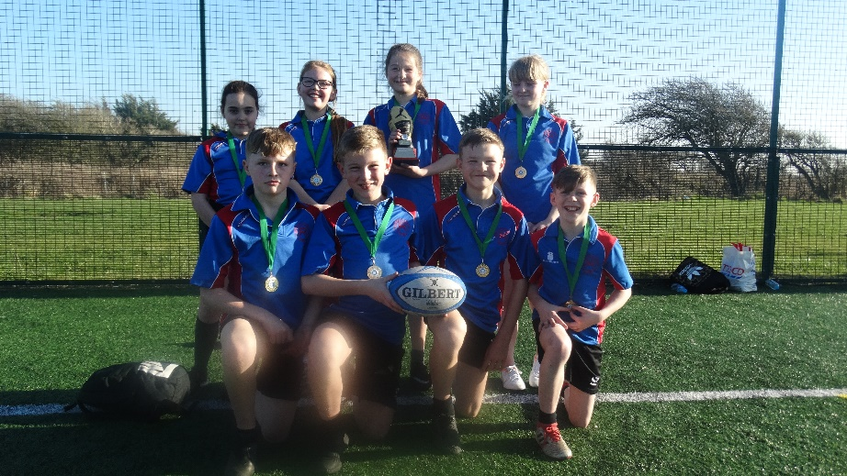
St Peters – BLA SSCO Year 5/6 Tag Rugby Champions

Lewis from Morecambe Road – BLA SSCO Tag Rugby Star Award

EVENT 10: YEAR 5/6 HIGH 5 NETBALL COMPETITION
Number | School/Team Name
1 | West End Lightning
2 | BLS Mavericks
3 | BLS Thunder
4 | Grosvenor Park Storm
5 | Grosvenor Park Sirens
6 | Overton Stars
7 | Overton Dragons
8 | Trumacar Hurricanes
9 | Sandylands Flames
10 | Slyne Devils
11 | Slyne Wasps
12 | Westgate Giants
13 | Westgate Blaze
14 | Mossgate Panthers
15 | St Peters Blizzard
TEAMS INVOLVED:

Format
- 15 teams split into 3 groups, playing each other once.
- 1ST AND 2ND in each group qualify for the knockout stages
- Two highest placed 3rd place teams also qualify for the knockout stages
- Other 3rd place, 4th and 5th in each group are out
- Straight knockout stages
- Championship group all play each other, top team wins trophy, runner up wins Silver medals
- Bronze group all play each other, top wins the bronze medals

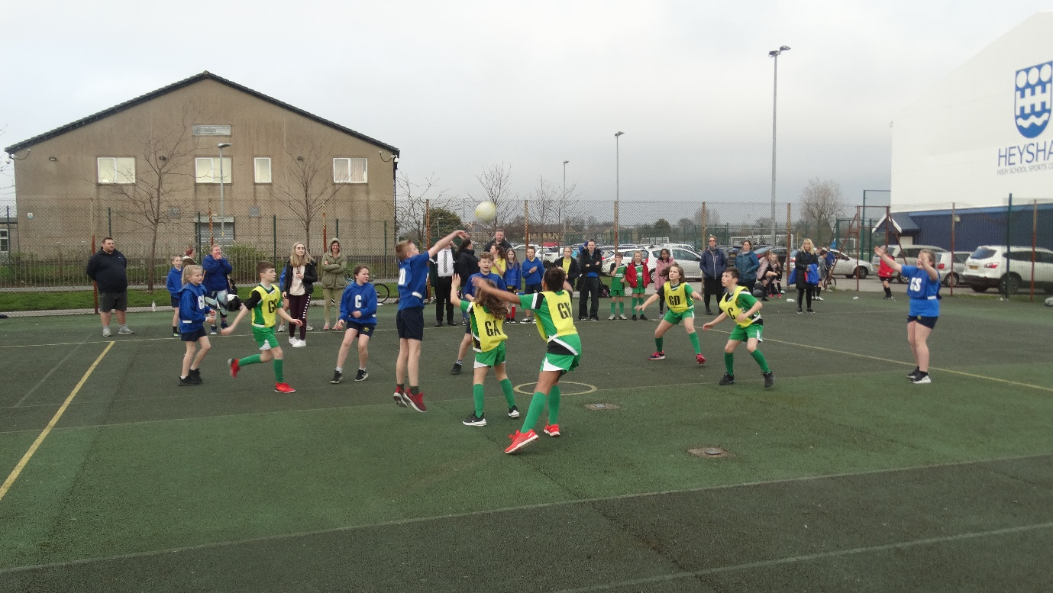

FIXTURES & RESULTS:
FIXTURES/RESULTS
TIME | COURT 1 | RES |  | COURT 2 | RES |  | COURT 3 | RES |  | COURT 4 | RES
3.35pm | GROUP A  SLYNE WASPS v GROSVENOR PARK SIRENS | 0 | 1 | GROUP B  MOSSGATE PANTHERS v OVERTON STARS | 0 | 0 | GROUP C  OVERTON DRAGONS v TRUMACAR HURRICANES | 0 | 0 | GROUP A  SP BLIZZARD v BLS MAVERICKS | 1 | 1
 | GROUP A  SANDYLANDS FLAMES v SP BLIZZARD | 1 | 5 | GROUP B  WEST END LIGHTNING v SLYNE DEVILS | 0 | 2 | GROUP C  WESTGATE BLAZE v GROSVENOR PARK STORM | 0 | 0 | GROUP B  OVERTON STARS v WESTGATE GIANTS | 0 | 1
 | GROUP A  BLS MAVERICKS v SLYNE WASPS | 5 | 0 | GROUP B  WESTGATE GIANTS v WEST END LIGHTNING | 0 | 0 | GROUP C  BLS THUNDER v WESTGATE BLAZE | 0 | 1 | GROUP B  SLYNE DEVILS v MOSSGATE PANTHERS | 5 | 0
 | GROUP A  BLS MAVERICKS v GROSVENOR PARK SIRENS | 1 | 1 | GROUP B  SLYNE DEVILS v OVERTON STARS | 1 | 0 | GROUP C  GROSVENOR PARK STORM v OVERTON DRAGONS | 0 | 2 | GROUP A  SLYNE WASPS v SP BLIZZARD | 0 | 6
 | GROUP A  SANDYLANDS FLAMES v SLYNE WASPS | 3 | 0 | GROUP B  WESTGATE GIANTS v MOSSGATE PANTHERS | 2 | 0 | GROUP C  GROSVENOR PARK STORM v TRUMACAR HURRICANES | 0 | 3 | GROUP C  BLS THUNDER v OVERTON DRAGONS | 2 | 0
 | GROUP A  SP BLIZZARD v GROSVENOR PARK SIRENS | 0 | 0 | GROUP B  MOSSGATE PANTHERS v WEST END LIGHTNING | 0 | 4 | GROUP C  OVERTON DRAGONS v WESTGATE BLAZE | 1 | 0 | GROUP B  WESTGATE GIANTS v SLYNE DEVILS | 1 | 0
 | GROUP A  SANDYLANDS FLAMES v BLS MAVERICKS | 0 | 3 | GROUP B  WEST END LIGHTNING v OVERTON STARS | 4 | 0 | GROUP C  BLS THUNDER v GROSVENOR PARK STORM | 2 | 0 | GROUP C  WESTGATE BLAZE v TRUMACAR HURRICANES | 2 | 1
 | GROUP A  GROSVENOR PARK SIRENS v SANDYLANDS FLAMES | 1 | 0 |  |  |  | GROUP C  TRUMACAR HURRICANES v BLS THUNDER | 0 | 1
 | QF 1  GRP A WINNER v 3RD PLACE  SP BLIZZARDS v WEST END LIGHTNING  (AET) | 3 | 2 | QF 2  GRP B WINNER v 3RD PLACE  WESTGATE GIANTS v GROSVENOR PARK SIRENS | 1 | 0 | QF 3  GRP C WINNER v GRP A RUNNER UP  BLS THUNDER v BLS MAVERICKS | 0 | 1 | QF 4  GRP B RUNNER UP v GRP C RUNNER UP  SLYNE DEVILS v OVERTON DRAGONS (AET) | 3 | 2
 |  |  |  | SF 1  QF 1 WINNER v QF 2 WINNER  WESTGATE GIANTS v SP BLIZZARD | 0 | 1 | SF 2  QF 3 WINNER v QF 4 WINNER  BLS MAVERICKS v SLYNE DEVILS | 0 | 1
 |  |  |  | FINAL  SF 1 WINNER v SF 2 WINNER  SP BLIZZARD v SLYNE DEVILS | 0 | 1 | 3RD/4TH PLAYOFF  SF 1 LOSER v SF 2 LOSER  BLS MAVERICKS v WESTGATE GIANTS | 2 | 0
6.00pm | PRESENTATION

CHAMPIONS: SLYNE WITH HEST DEVILS
2nd Place: ST PETERS BLIZZARD (Silver Medals)
3rd Place: BLS MAVERICKS (Bronze Medals)
4TH PLACE: WESTGATE GIANTS

GROUP STAGES:
GROUP A
POS | TEAMS | GOALS FOR |  |  |  | GOALS AGAINST |  |  |  | GD | POINTS |  |  |  | TOTAL
1 | St Peters Blizzard | 1 | 5 | 6 | 0 | 1 | 1 | 0 | 0 | +10 | 3 | 5 | 5 | 3 | 16
2 | BLS Mavericks | 1 | 5 | 1 | 3 | 1 | 0 | 1 | 0 | +8 | 3 | 5 | 3 | 5 | 16
3 | *Grosvenor Park Sirens | 1 | 1 | 0 | 1 | 0 | 1 | 0 | 0 | +2 | 5 | 3 | 3 | 5 | 16
4 | Sandylands Flames | 1 | 3 | 0 | 0 | 5 | 0 | 3 | 1 | -5 | 0 | 5 | 0 | 0 | 5
5 | Slyne Wasps | 0 | 0 | 0 | 0 | 1 | 5 | 6 | 3 | -15 | 0 | 0 | 0 | 0 | 0

GROUP B
POS | TEAMS | GOALS FOR |  |  |  | GOALS AGAINST |  |  |  | GD | POINTS |  |  |  | TOTAL
1 | Westgate Giants | 1 | 0 | 2 | 1 | 0 | 0 | 0 | 0 | +4 | 5 | 3 | 5 | 5 | 18
2 | Slyne Devils | 2 | 5 | 1 | 0 | 0 | 0 | 0 | 1 | +7 | 5 | 5 | 5 | 0 | 15
3 | *West End Lightning | 0 | 0 | 4 | 4 | 2 | 0 | 0 | 0 | +6 | 0 | 3 | 5 | 5 | 13
4 | Overton Stars | 0 | 0 | 0 | 0 | 0 | 1 | 1 | 4 | -6 | 3 | 0 | 0 | 0 | 3
5 | Mossgate Panthers | 0 | 0 | 0 | 0 | 0 | 5 | 2 | 4 | -11 | 3 | 0 | 0 | 0 | 3

GROUP C
POS | TEAMS | GOALS FOR |  |  |  | GOALS AGAINST |  |  |  | GD | POINTS |  |  |  | TOTAL
 | BLS Thunder | 0 | 2 | 2 | 1 | 1 | 0 | 0 | 0 | +6 | 0 | 5 | 5 | 5 | 15
 | Overton Dragons (H2H) | 0 | 2 | 0 | 1 | 0 | 0 | 2 | 0 | +1 | 3 | 5 | 0 | 5 | 13
 | Westgate Blaze | 0 | 1 | 0 | 2 | 0 | 0 | 1 | 1 | +1 | 3 | 5 | 0 | 5 | 13
 | Trumacar Hurricanes | 0 | 3 | 1 | 0 | 0 | 0 | 2 | 1 | +1 | 3 | 5 | 1 | 0 | 9
 | Grosvenor Park Storm | 0 | 0 | 0 | 0 | 0 | 2 | 3 | 2 | -7 | 3 | 0 | 0 | 0 | 3
*One of the two best 3rd placed teams qualify for knockout phase
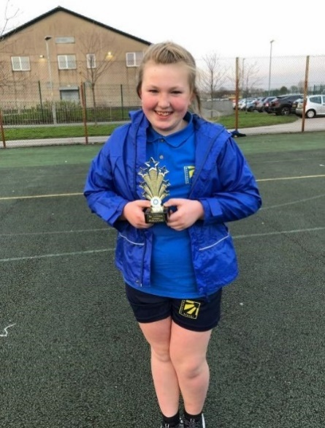

Ferrara from Westgate – BLA SSCO Year 5/6 High 5 Netball Star Award

Slyne with Hest – BLA SSCO Year 5/6 High 5 Netball Champions

EVENT 11: YEAR 5/6 QUICKSTICKS HOCKEY COMPETITION
NUMBER | TEAMS
1 | Trumacar Jets
2 | West End Coyotes
3 | Westgate Maple Leaf’s
4 | Slyne Avalanche
5 | Bolton le sands Bruins
6 | Bolton le sands Blackhawks
7 | Sandylands Hurricanes
8 | Westgate Flyers
9 | Westgate Redwings
10 | St Peters Sabres
11 | Slyne Predators
12 | Slyne Ducks
13 | Slyne Knights
14 | Mossgate Flames
15 | Mossgate Islanders
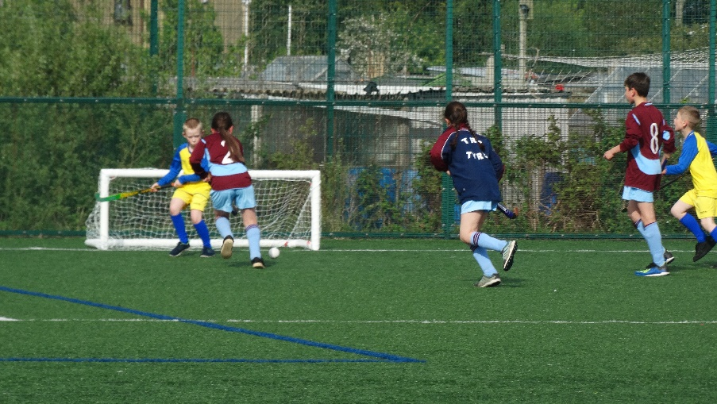
TEAMS INVOLVED:

Format
Stage 1:

- I have split the teams into three groups Group A, Group B and Group C.
- All teams play all others in their group

Stage 2:

- Top team in each group qualify for the Championship Group (Gold & Silver medals & Trophy)
- Top team in Championship Group Wins Gold medals and Trophy.
- Second in Championship Group Wins Silver medals
- Second in each group qualify for Bronze Medal Group
- Top team in Bronze Medal Group wins Bronze Medals
- 3RD, 4TH AND 5TH in Group stages will be out of the event.

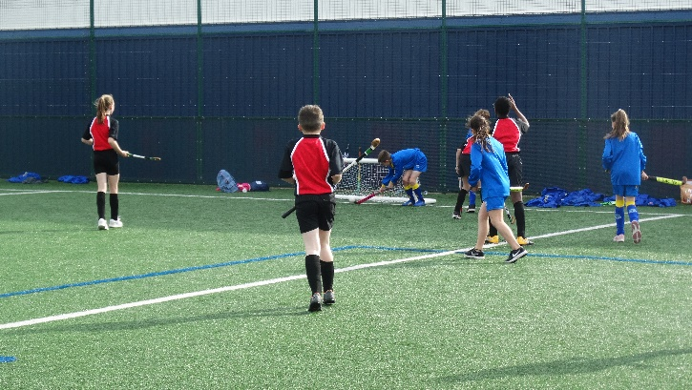

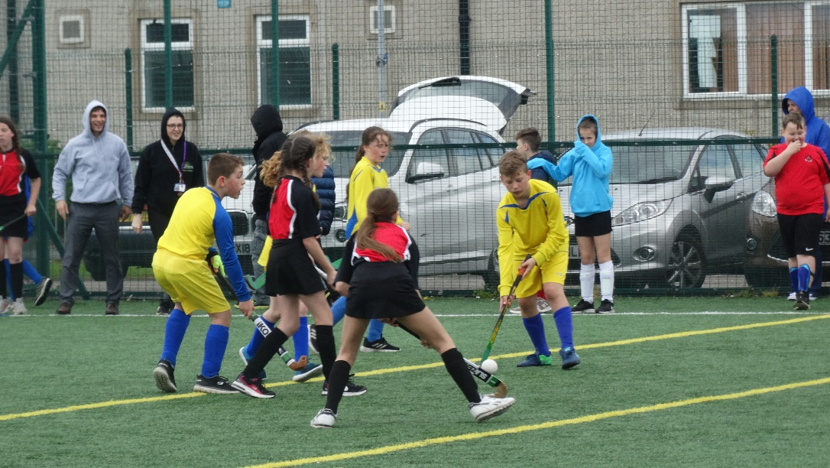

FIXTURES & RESULTS:

FIXTURES/RESULTS
TIME | PITCH 1 | RES |  | PITCH 2 | RES |  | PITCH 3 | RES |  | PITCH 4 | RES
3.50pm | GROUP A  WESTGATE MAPLE LEAFS v SLYNE AVALANCHE | 0 | 2 | GROUP B  BLS BLACKHAWKS v TRUMACAR JETS | 1 | 0 | GROUP C  WEST END COYOTES v SLYNE PREDATORS | 1 | 3 | GROUP A  SP SABRES v SLYNE DUCKS | 3 | 0
 | GROUP A  SLYNE DUCKS v WESTGATE MAPLE LEAFS | 0 | 0 | GROUP B  WESTGATE REDWINGS v SLYNE KNIGHTS | 0 | 2 | GROUP C  WESTGATE FLYERS v BLS BRUINS | 0 | 3 | NO GAME
 | GROUP A  MOSSGATE FLAMES v SP SABRES | 1 | 2 | GROUP B  SANDYLANDS HURRICANES v WESTGATE REDWINGS | 1 | 0 | GROUP C  MOSSGATE ISLANDERS v WESTGATE FLYERS | 2 | 0 | GROUP B  SLYNE KNIGHTS v BLS BLACKHAWKS | 0 | 1
 | GROUP A  SP SABRES v SLYNE AVALANCHE | 5 | 0 | GROUP B  SANDYLANDS HURRICANES v SLYNE KNIGHTS | 1 | 1 | GROUP C  BLS BRUINS v WEST END COYOTES | 3 | 0 | GROUP C  SLYNE PREDATORS v MOSSGATE ISLANDERS | 2 | 2
 | GROUP A  SLYNE DUCKS v SLYNE AVALANCHE | 0 | 2 | GROUP B  SLYNE KNIGHTS v TRUMACAR JETS | 1 | 0 | GROUP C  BLS BRUINS v SLYNE PREDATORS | 0 | 2 | GROUP C  MOSSGATE ISLANDERS v WEST END COYOTES | 5 | 0
 | GROUP A  MOSSGATE FLAMES v WESTGATE MAPLE LEAFS | 0 | 0 | GROUP B  SANDYLANDS HURRICANES v BLS BLACKHAWKS | 0 | 2 | GROUP C  WESTGATE FLYERS v SLYNE PREDATORS | 0 | 2 | GROUP B  WESTGATE REDWINGS v TRUMACAR JETS | 1 | 0
 | GROUP A  WESTGATE MAPLE LEAFS v SP SABRES | 0 | 4 | GROUP B  BLS BLACK HAWKS v WESTGATE REDWINGS | 3 | 1 | GROUP C  WEST END COYOTES v WESTGATE FLYERS | 3 | 0 | GROUP A  SLYNE AVALANCHE v MOSSGATE FLAMES | 2 | 3
 | GROUP A  MOSSGATE FLAMES v SLYNE DUCKS | 0 | 2 | GROUP B  TRUMACAR JETS v SANDYLANDS HURRICANES | 0 | 2 | GROUP C  MOSSGATE ISLANDERS v BLS BRUINS | 0 | 2 | NO GAME
 | QF 1  GRP A WINNER v 3RD PLACE  SP SABRES v SANDYLANDS HURRICANES | 2 | 0 | QF 2  GRP B WINNER v 3RD PLACE  BLS BLACKHAWKS v MOSSGATE ISLANDERS | 1 | 0 | QF 3  GRP C WINNER v GRP A RUNNER UP  SLYNE PREDATORS v SLYNE AVALANCHE | 2 | 1 | QF 4  GRP B RUNNER UP v GRP C RUNNER UP  SLYNE KNIGHTS v BLS BRUINS | 0 | 1  GG
 | SF 1  QF 1 WINNER v QF 2 WINNER  SP SABRES v BLS BRUINS | 2 | 0 |  |  |  | SF 2  QF 3 WINNER v QF 4 WINNER  SLYNE PREDATORS v BLS BLACKHAWKS | 0 | 1  GG
 | FINAL  SF 1 WINNER v SF 2 WINNER  SP SABRES v BLS BLACKHAWKS | 0 | 1 |  |  |  | 3RD/4TH PLAYOFF  SF 1 LOSER v SF 2 LOSER  BLS BRUINS v SLYNE PREDATORS | 0 | 0
5.50pm | PRESENTATION
FINAL RESULTS
CHAMPIONS: BOLTON LE SANDS BLACKHAWKS
2nd Place: ST PETERS SABRES (Silver Medals)
JOINT 3rd Place: SLYNE PREDATORS & BLS BRUINS (Bronze Medals)
GROUP STAGES:

GROUP A
POS | TEAMS | GOALS FOR |  |  |  | GOALS AGAINST |  |  |  | GD | POINTS |  |  |  | TOTAL
1 | St Peters Sabres | 3 | 2 | 5 | 4 | 0 | 1 | 0 | 0 | +13 | 3 | 3 | 3 | 3 | 12
2 | Slyne Avalanche | 2 | 0 | 2 | 2 | 0 | 5 | 0 | 3 | -2 | 3 | 0 | 3 | 0 | 6
3 | Mossgate Flames | 1 | 0 | 3 | 0 | 2 | 0 | 2 | 2 | -2 | 0 | 1 | 3 | 0 | 4
4 | Slyne Ducks | 0 | 0 | 0 | 2 | 3 | 0 | 2 | 0 | -3 | 0 | 1 | 0 | 3 | 4
5 | Westgate Maple Leaf’s | 0 | 0 | 0 | 0 | 2 | 0 | 0 | 4 | -6 | 0 | 1 | 1 | 0 | 2

GROUP B
POS | TEAMS | GOALS FOR |  |  |  | GOALS AGAINST |  |  |  | GD | POINTS |  |  |  | TOTAL
1 | Bolton le Sands Blackhawks | 1 | 1 | 2 | 3 | 0 | 0 | 0 | 1 | +6 | 3 | 3 | 3 | 3 | 12
2 | Slyne Knights | 2 | 0 | 1 | 1 | 0 | 1 | 1 | 0 | +2 | 3 | 0 | 1 | 3 | 7
3 | Sandylands Hurricanes | 1 | 1 | 0 | 2 | 0 | 1 | 2 | 0 | +1 | 3 | 1 | 0 | 3 | 7
4 | Westgate Redwings | 0 | 0 | 1 | 1 | 2 | 1 | 0 | 3 | -4 | 0 | 0 | 3 | 0 | 3
5 | Trumacar Jets | 0 | 0 | 0 | 0 | 1 | 1 | 1 | 2 | -5 | 0 | 0 | 0 | 0 | 0

GROUP C
POS | TEAMS | GOALS FOR |  |  |  | GOALS AGAINST |  |  |  | GD | POINTS |  |  |  | TOTAL
1 | Slyne Predators | 3 | 2 | 2 | 2 | 1 | 2 | 0 | 0 | +6 | 3 | 1 | 3 | 3 | 10
2 | Bolton le Sands Bruins | 3 | 3 | 0 | 2 | 0 | 0 | 2 | 0 | +6 | 3 | 3 | 0 | 3 | 9
3 | Mossgate Islanders | 2 | 2 | 5 | 0 | 0 | 2 | 0 | 2 | +5 | 3 | 1 | 3 | 0 | 7
4 | West End Coyotes | 1 | 0 | 0 | 3 | 3 | 5 | 0 | 0 | -4 | 0 | 0 | 0 | 3 | 3
5 | Westgate Flyers | 0 | 0 | 0 | 0 | 3 | 2 | 2 | 3 | -10 | 0 | 0 | 0 | 0 | 0
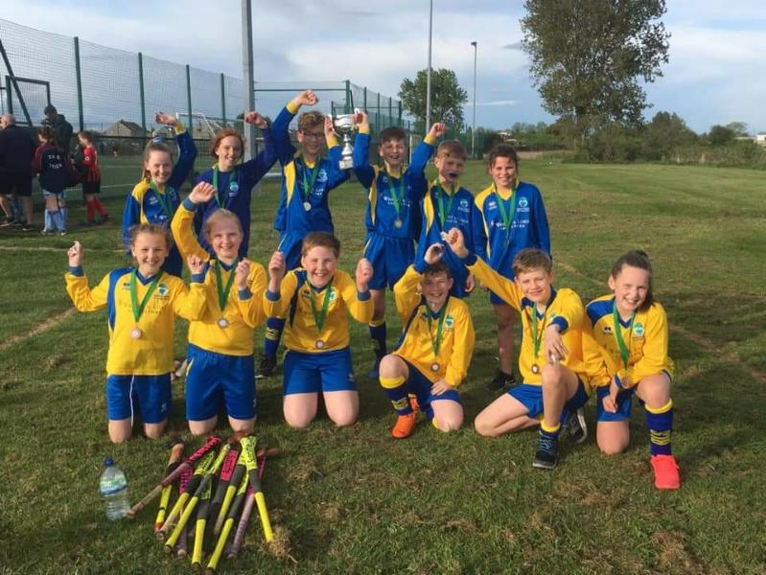
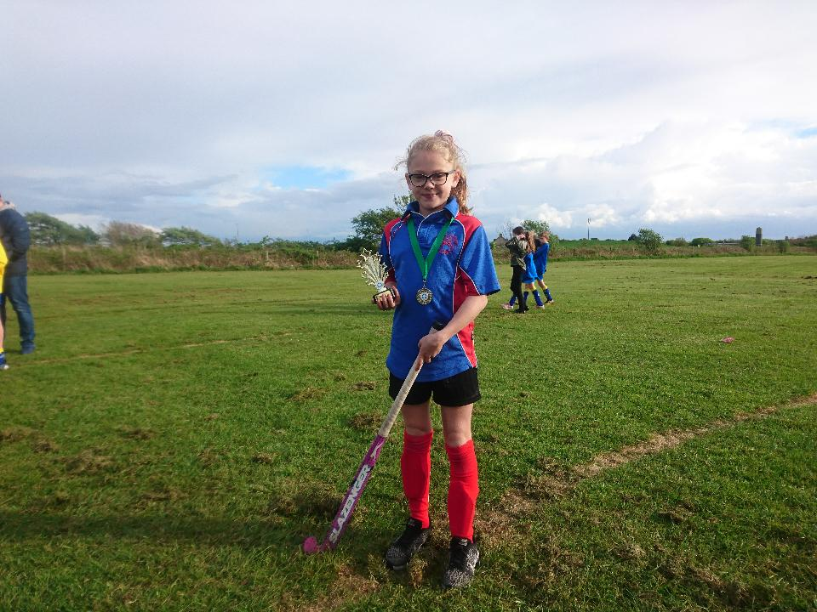

Bolton le Sands – BLA SSCO Year 5/6 Quicksticks Hockey Champions

Shienna from St Peters – BLA SSCO Year 5/6 Quicksticks Hockey Star Award

EVENT 12: YEAR 5/6 ROUNDERS COMPETITION
NUMBER | TEAMS
1 | Sandylands Red Sox
2 | BLS Brewers
3 | Grosvenor Park Twins
4 | Grosvenor Park Mets
5 | Grosvenor Park Yankees
6 | Westgate Royals
7 | Westgate Braves
8 | West End Angels
9 | Slyne with Hest Cubs
10 | Slyne with Hest Giants
11 | Slyne with Hest Marlins
12 | St Peters Aviators
TEAMS INVOLVED:
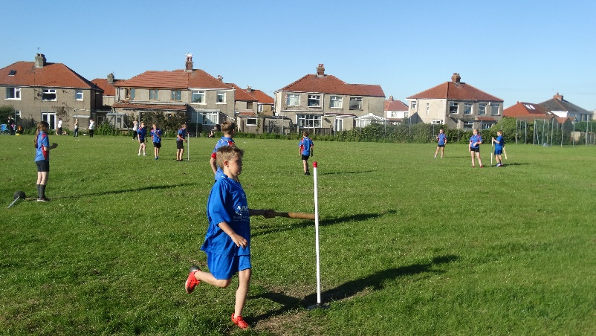

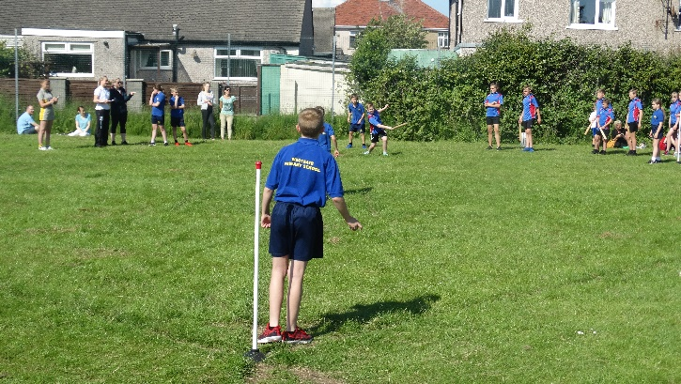
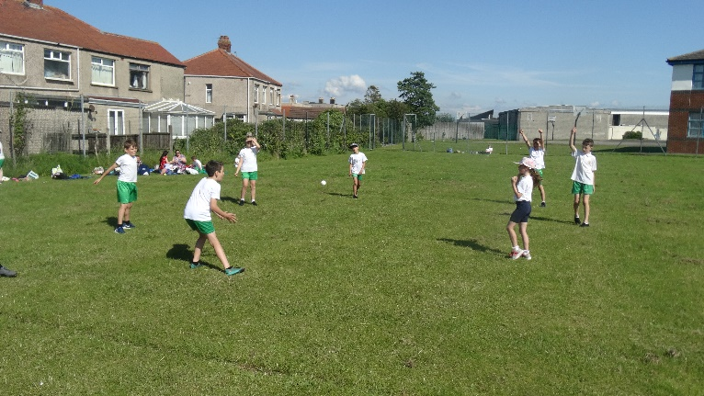

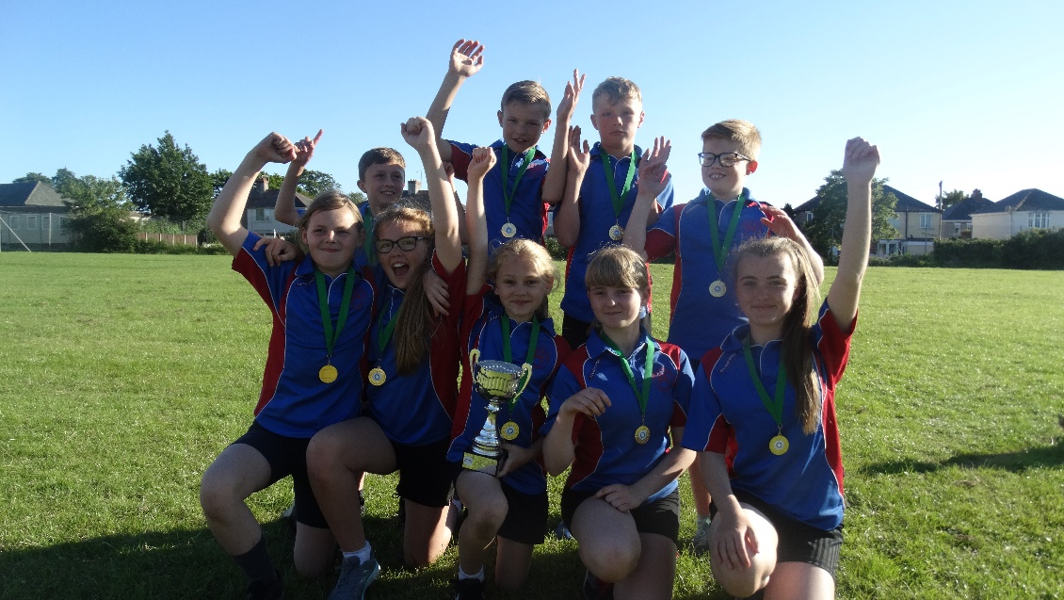

St Peters – BLA SSCO Year 5/6 Rounders Champions

EVENT 13: CHANGE 4 LIFE/INFLATABLE FESTIVAL
TEAMS
Grosvenor Park
Westgate
St Peters
West End
Slyne with Hest
Grosvenor Park
TEAMS INVOLVED:

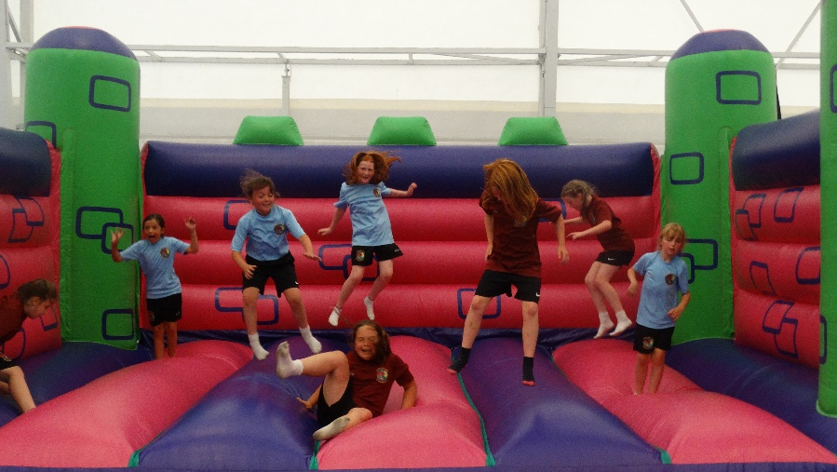

BOUNCY CASTLE

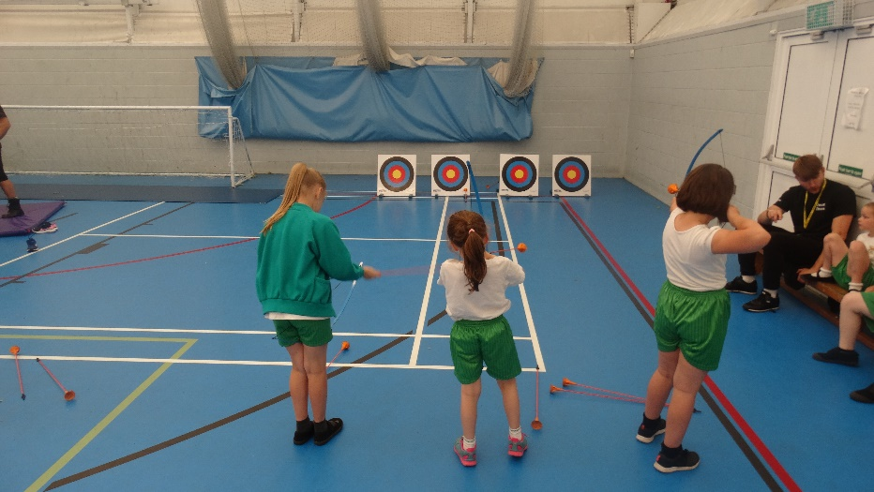

ARCHERY

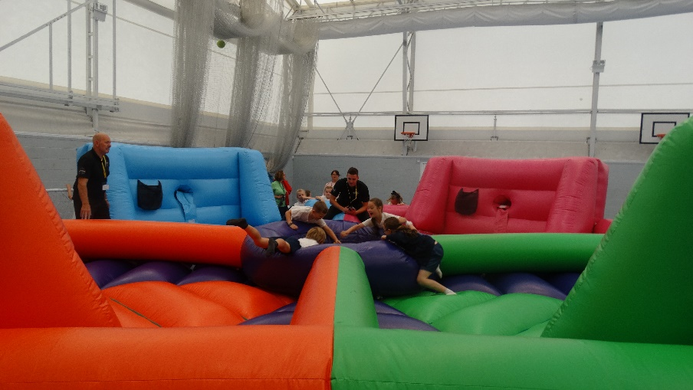

HUNGRY HIPPOS

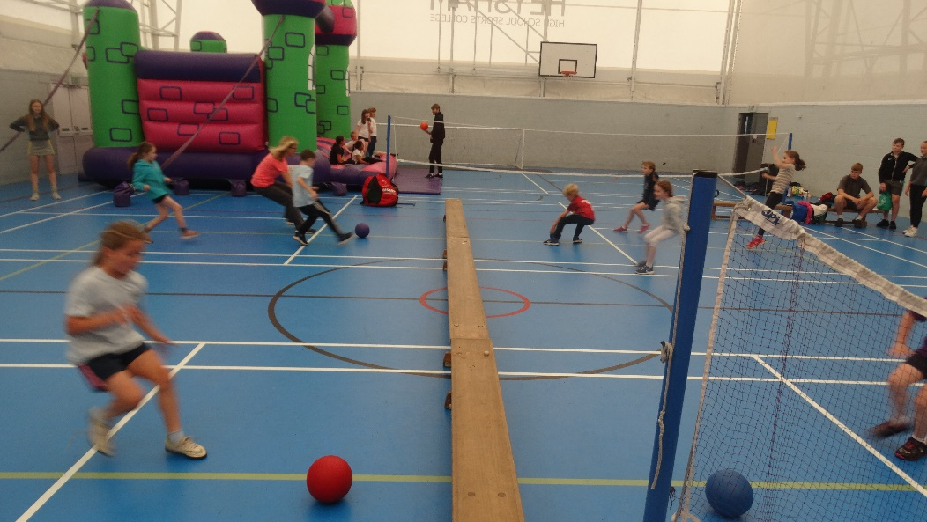
DODGEBALL & MULTI-SKILLS ACTIVITIES

EVENT 14: YEAR 5/6 AQUATHLON (Swim & Run)
TEAMS
Slyne with Hest Purple
Slyne with Hest Blue
Slyne with Hest White
Westgate
BLS
Grosvenor Park
TEAMS INVOLVED:

Format
- Teams swim 2 lengths (50m), then transition at the fire exit of pool.
- Pop a t-shirt & trainers on and complete the run which finishes on the athletics track (grass field behind tentile sports hall.
- Competitors will walk the course altogether before competing, with tape helping outline the course.
- ALL competitors’ times will be taken down, with top 3 scores added together for team event, with the quickest accumulative time winning Gold etc. The 3 best individual times winning Bronze, Silver & Gold.
- Slyne Purple will go first, with the team members completing the course before the next team (Westgate) start, and so on.
- Once teams have completed their turn, return to the pool and get changed and give in their results to central desk. Stop watches will be provided.

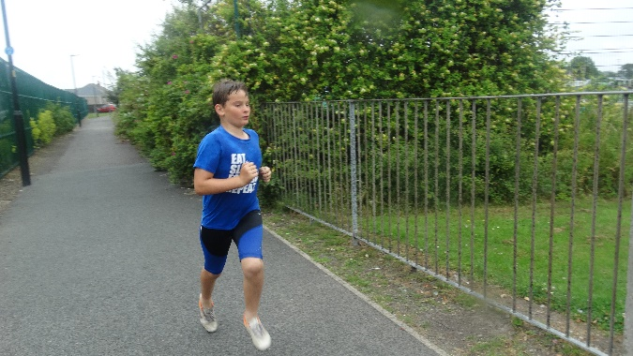

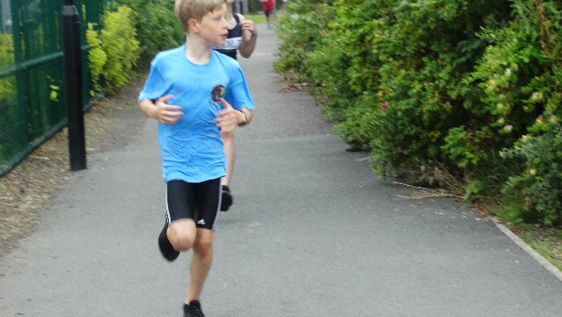

ORDER & TIMINGS:

SLOT | SCHOOL | COMPETITOR 1 TIME | COMPETITOR 2 TIME | COMPETITOR 3 TIME | COMPETITOR 4 TIME | COMPETITOR 5 TIME | TOTAL  (Top 3 count)
1 | SLYNE PURPLE | 5m 10s | 5m 14s | 5m 17s | 5m 19s | 5m 56s | 15m 32s
2 | WESTGATE | 4m 41s | 4m 35s | 5m 38s | 5m 54s | 6m 15s | 14m 14s
3 | SLYNE BLUE | 4m 26s | 4m 46s | 5m 00s | 5m 15s | - | 14m 12s
4 | BLS | 4m 11s | 4m 14s | 4m 37s | 4m 56s | 4m 58s | 13m 02s
5 | GROSVENOR PARK | 3m 52s | 4m 38s | 4m 44s | 4m 54s | 5m 25s | 12m 34s
6 | SLYNE WHITE | 4m 02s | 4m 19s | 4m 32s | 4m 57s | - | 12m 53s

FIXTURES & RESULTS:
TEAM EVENT SCORING
POSITION | SCHOOL | TEAM TIME
1ST | GROSVENOR PARK | 12m 34s
2ND | SLYNE WHITE | 12m 53s
3RD | BOLTON LE SANDS | 13m 02s
4TH | SLYNE BLUE | 14m 12s
5TH | WESTGATE | 14m 14s
6TH | SLYNE PURPLE | 15m 32s

INDIVIDUAL EVENT SCORING
POSITION | SCHOOL | COMPETITOR TIME
GOLD | SETH (Grosvenor Park) | 3m 52s
SILVER | EVIE (Slyne White) | 4m 02s
BRONZE | LEWIS (BLS) | 4m 11s

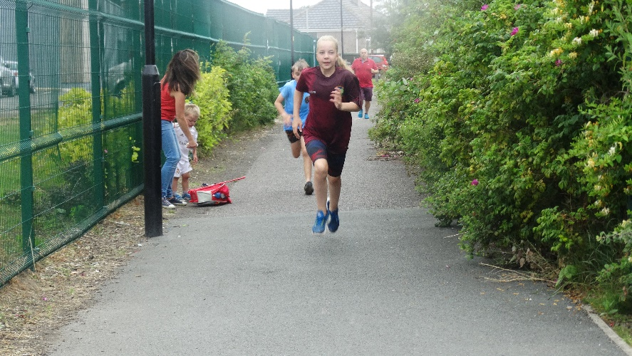
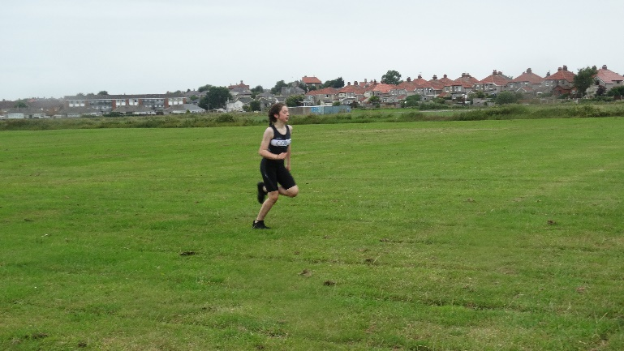

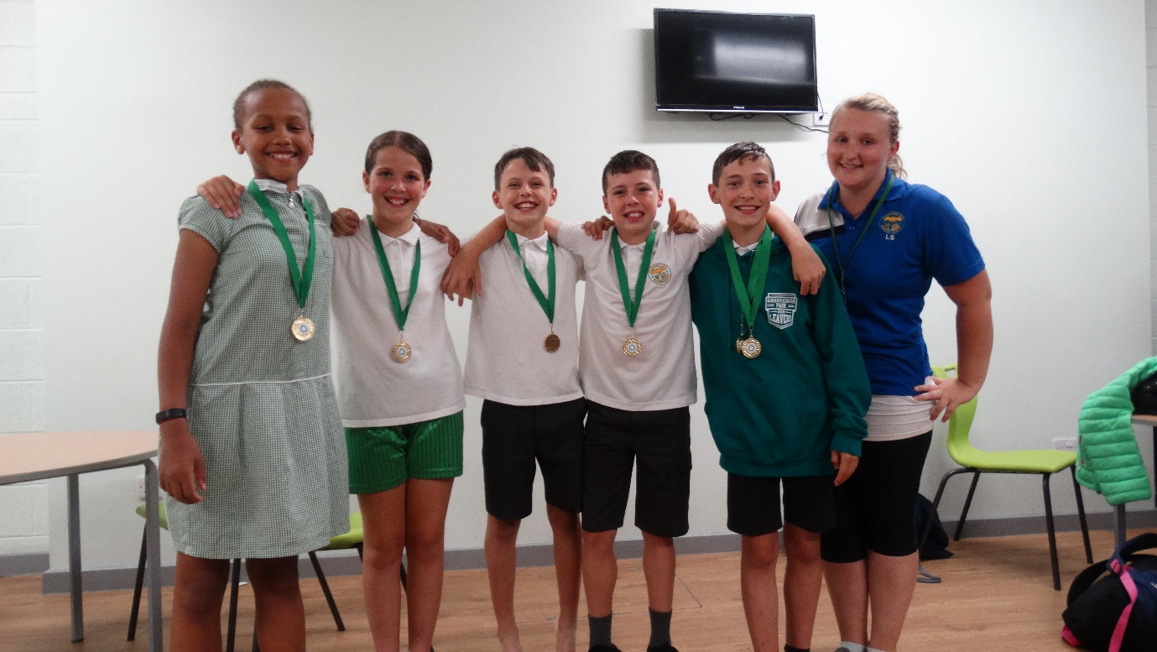

Grosvenor Park – BLA SSCO Year 5/6 Aquathlon Champions

2018-2019 STAFF CPD

GYMNASTICS EQUIPMENT CPD

Utilising the fantastic pupils at Bolton le Sands and their equipment. Glenn Swindlehurst provided quality examples of gymnastics activities to do on equipment.
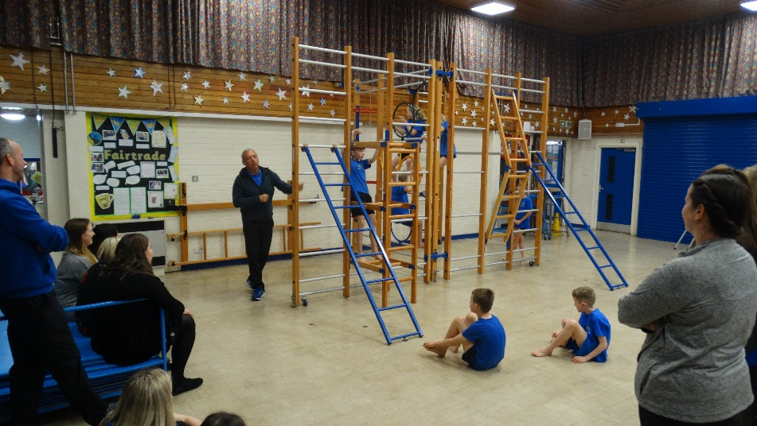

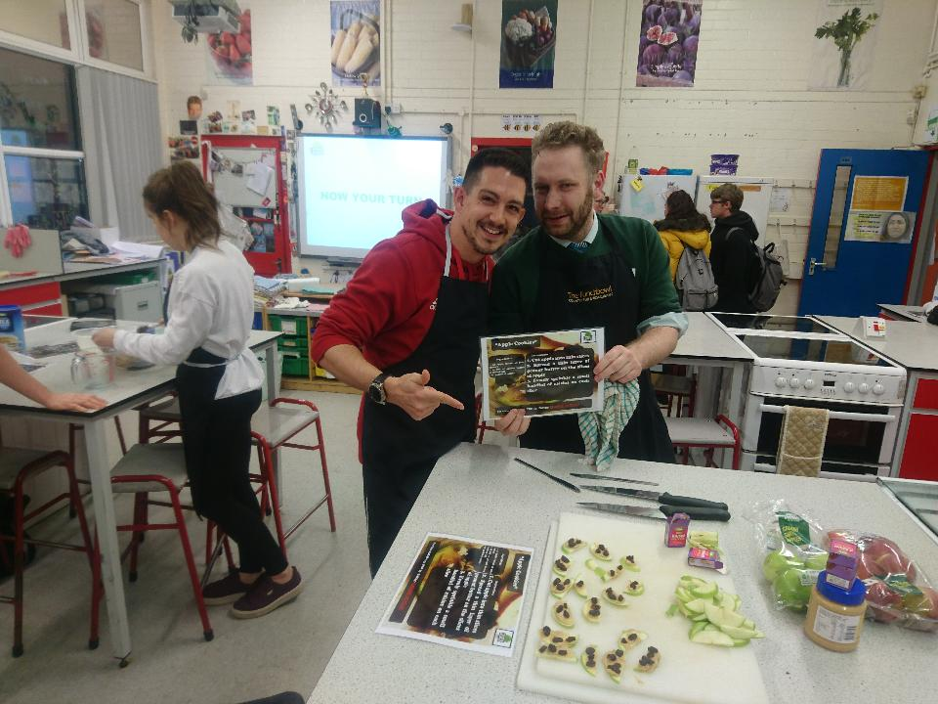
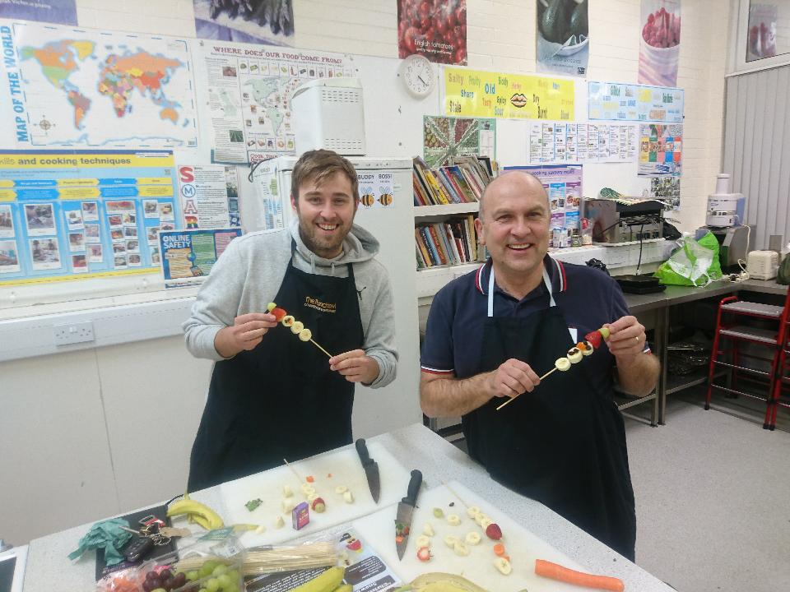
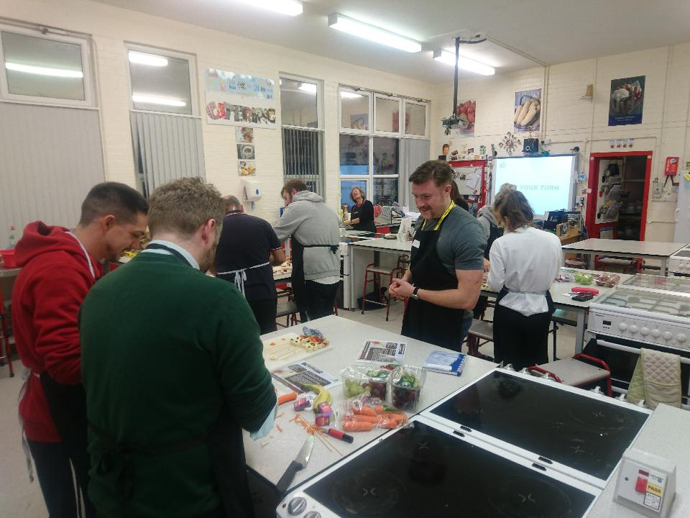
NUTRITION CPD

- Delivered by quality nutritionist – Mike Lynne
- Delegates worked in small groups and made some fantastic healthy snacks, rotating around several recipes.
- Whilst cooking, Mike also discussed the importance of nutrition and how it can be delivered in schools.
- Includes 5 healthy snack recipes.

