Transition Day @ The Health Innovation Campus, Lancaster University!


Dear Colleague,
We would like to invite your school to the new and exciting… Climate Action Transition Day 2025 taking place at Health Innovation One, Lancaster University, Bailrigg, Lancaster, LA1 4AT. This event will see children from across Lancaster come together to build confidence and self-esteem as they transition to high school. We would like schools to bring 6-8 children from KS2 and KS3, specifically years 5, year 6 and year 7 to take part in a ‘Climate Challenge Survival Transition Day’ Venue specific information will follow upon registering for the event. Pupils will step into a real life computer game type event!
09:00 arrive for a 10:00 start and the event should finish no later than 14:30.The Transition Day will run in the midst of a post-apocalyptic climate crisis! Children must work together to solve puzzles, learning about our local flora and fauna, learning what plants and animals need to survive and thrive, seeing things from different perspectives and working together to earn time in the mass group game at the end of the day. Think Crystal Maze meets Krypton Factor meets Mad Max!
Schools are encouraged to bring a targeted group of year 5/6/7 who perhaps don’t enjoy ‘traditional’ sports but may enjoy something different, or those could struggle socially and emotionally. We want to give children an experience that they may never have had before or again and build their confidence in order to aid transition to high school.
If you’d like to be involved, please book via our website & see below for further details. For any more information please contact:
Lancaster Schools:
Dan Morris- danmorrislhssn@gmail.com or Steven Jamieson- jamieson.sm@gmail.com
We look forward to hearing from you!


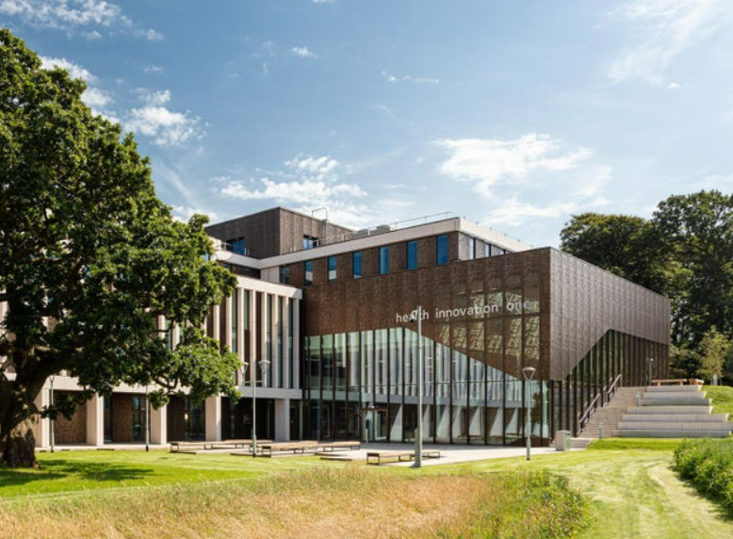

Activity Outcome
For children who are about to transition to high school and children who have recently transitioned to experience a challenge day working as part of a team in the beautiful surroundings of the Health Innovation Campus! The aim is to work through puzzles and problems in outdoor surroundings with a theme on our environment and climate action!

Purpose
Finding new ways to help children with the transition to high school
Who Is It for?
Upper KS2 and Lower KS3
Entry Criteria
Schools should select between 6 - 8 pupils (mixed, no ratio)- please just let us know how many you intend to bring when entering. Schools are encouraged to select a targeted group who perhaps have low self-esteem or confidence and may find the transition from primary school to high school difficult. This event would also be good to build confidence with children who have recently transitioned to high school.
Format
Schools will all meet at Health Innovation One where they will have chance to mingle with their fellow participants. They will then be briefed about the rules of the game. Instructions, timesheets and score sheets will be given to the teams before they set off from the HIC on a pre planned route around the woodland trail of Lancaster Campus. Along the way, they will encounter puzzles and problems to solve in order to earn ‘golden pine cones’ which earn time for the final game Hill of Hell! Think Crystal Maze meets Fallout meets Captain Planet! (for you oldies) Participants may be mixed between schools to encourage social connections.
Equipment
Please come ready for outdoor activities in weather with trainers, a drink and a packed lunch.
Location & Logistics
Activities will take place at the HIC. There is paid parking but if you are arriving by minibus or coach then please do let us know when you are booking. There may be transport available depending on bookings. We will know closer to the time.

Event details are as follows:
- Arrive at 09:30 for a 10:00 start and finish at 14:30 at the latest.
- Schools encouraged to bring a mixture of team members and staff willing to participate and throw themselves into the role play and strategy part of the event
- Wear outdoor clothes.sturdy trainers or boots and a waterproof as all activities will be outside. Students are encouraged to rip or tear old clothes, or dress up to enhance the ‘Apocalyptic survival climate emergency feel’
- Groups of 6-8 pupils (please confirm numbers prior)
- Date: 16th June (Deadline 13th June but may fill sooner so don't delay!)
- Venue: Health Innovation One
- Please do not arrive more than 15 minutes before the start time.
- Please can schools bring their own 1st Aid kits & an adult per school group
- It will fill up fast!!!

- The activity is taking place at the new Health Innovation One, Lancaster University, Bailrigg, Lancaster, LA1 4AT
- Parking for coaches will be confirmed closer to the time. Please let us know if your minibus or coach will be staying for the duration of the event or dropping off. There is also paid car parking on site.
- There are water fountains, vending machines and a vending coffee machine at the HIC for staff refreshments
- Although there are first aiders on site, schools should bring their own first aid kits and school staff should be the first port of call.
- Please wear outdoor clothes and footwear
Venue Map- More details will follow.
