Bay Leadership Academy
Osborne Road
Morecambe
Lancashire
LA3 1AB
14th September 2025
Dear Primary Colleague
I would like to invite your school to compete in the next BLA SSCO Programme sports competition – the 5/6 Acro Gymnastics competition, scheduled for Tuesday 16th December starting at 3.45pm and finish approx. 6.15pm, depending on entries.
This event will take place in BLA sports hall, located in main school, through main reception on Osborne Road. There is ample parking opposite the astro pitch, with the reception just along the path near the swimming pool.
Details of the competition are as follows:
- Scheduled for Tuesday 16th December
- Start at 3.45pm, finish approx. 6.15pm
- Venue: BLA Sports Hall
- Select from relevant year groups.
Routine Information:
- Acro routine, lasting maximum of 2 minutes
- 9 moves, pick one from each row A to I from the accompanying gymnastics document, pick based on your gymnast’s ability.
- The skills increase in difficulty from columns 1-3. Column 1 being the easiest version and column 3 being the most difficult version
- Routines should include choreography that mirrors the tone and feel of the music. Transition moves such as: cat leaps, step ball changes, skipping, etc should also be used to ensure pupils use the whole of the space provided and to link skills together
- Pick your own music – lyrics are permitted but should not include any Disney songs or musicals
- Each pair marked out of 10 – 8 points for 9 moves + 1 point for timing and linking actions + 1 point for general impression and fluidity
- Team Prizes (trophy & medals) AND Individual pair prizes (medals) including separate Boys Only/Girls Only/Mixed pairs
- Squads of up to 10 (minimum 6), split off into pairs, top 3 pairs scores count towards team score. CAN BRING JUST INDIVIDUALS IF YOU DO NOT HAVE ENOUGH FOR TEAM EVENT
- Please let me know team names and your music, any questions please do not hesitate to ask. EACH SCHOOL PUT SONGS IN ORDER OF YOUR PERFORMANCES AND SEND TO ME SO I CAN CHECK THEY WORK.
- You can use a website called WeTransfer. This site allows you to upload your music track and email it over to me to download for free. This might be helpful as I know sending large tracks can be difficult via email. WeTransfer | Send Large Files Fast
- Confirmation of format will be sorted after deadline entry day.

The deadline entry date for this event is Friday 24th October. Please enrol via our website – www.lhssn.co.uk

Sincerely,

Tim Fletcher
Bay Leadership Academy SSCO Programme Manager
Email: timothy.fletcher@bay.staracademies.org
Mobile: 07917 873 616
BLA SSCO Gymnastic Acrobatic Competition
A | 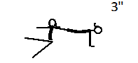 | 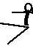  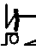  3” |  | 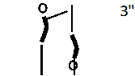
B | 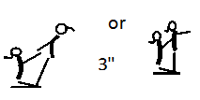 | 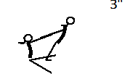 | 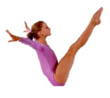  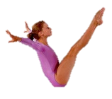  3”
C | 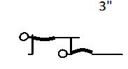 | 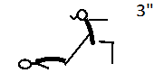 | 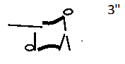
D | 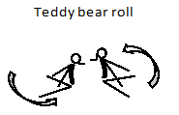 | 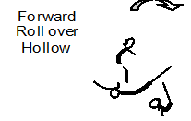 | 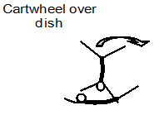
E | 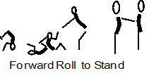 | 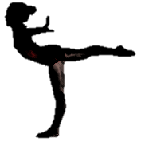  Arabesque 3” | 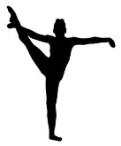  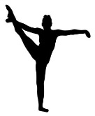  ‘Y’ Balance 3”
F | Front Support 2”  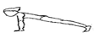 | 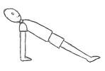  Back support 2” | 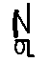  Bent Leg Headstand 2”
G | Straight Jump | Tuck Jump | Straight Jump half or full turn
H | Pencil Roll | Forward Roll to stand or straddle sit or straight jump | Backward Roll to feet or knees
I | One Leg Stand | Headstand | Cartwheel

A | As diagram. Position of Bases arms off the floor. Top shows strong front support position. Base can face inwards or outwards. | Base is sitting on the floor in a straddle position. Top is in bent leg headstand in tuck position and toes pointed. Base providing minimal support, arms of base must be straight. | The top should be in a balanced handstand with the base providing minimal support. A straight handstand is required from the top showing extension and good body tension.
B | A is in balance and B is in counterbalance. Arms of the base may be bent or straight when top is in balance. In counterbalance the top and bases arms must be straight. Base is kneeling with seat resting on heels. Face in or out. | The base sits in a straddle position and links hand with the top. The top leans away from the base using their linked hands to create a counterbalance. | V- Sit balance. Both in a V-sit shape, pressing feet together, with straight legs and arms out for balance. Chest held up as much as possible.
C | Top shows front support position. Base supports below the knee, arms straight. Base can have the legs slightly apart to make more stable. | Bases legs should be straight. The Top should be in chair position leaning back into the bases’ feet supported by the base in the lower back. | The top forms an extended flat bodyline, with the hands and shoulders over the knees of the base. The shoulders back and hips of the base should remain in contact with the floor. Both base and top should form continuous lines.
D | Gymnasts should be back-to-back at the start, each completes a half circle. Finishing back-to-back. Hand position optional | Base is in arch or dish; head, arms, shoulders and ankles are clear from the floor. Top performs a forward roll over their partner. | Base is in dish or arch; head, arms, shoulders and ankles are clear from the floor. B: Cartwheels over the waist with one arm either side.
E | The tumble should be smooth and Continuous. The hands should only contact the floor in entry to a roll. Additional steps are Not permitted. | Trunk vertical, back straight. Extend back leg with pointed foot as high as possible before lowering the shoulders. Move arms down to sides at shoulder height to help control the balance. | Partner ‘Y’ balance. Each person lifts their outside leg and holds to form the ‘Y’ position whilst holding their partners arm for balance.
F | Shoulders over hands, straight line from head to toe. Toes tucked under. Hold 2" | Shoulders over hands, straight line from head to toe with hips pushed up. Fingers pointing to toes. Hold for 2”. | Headstand Hold 2" Legs bent toes pointed. Tuck in front of the body. Fingers/hands should point towards the face/head (not like diagram).
G | The jump shape should be stretched out, feet pointing down towards the floor. Arms should swing up to the ears. No additional steps on landing permitted. | The jump should have sufficient height, with the knees coming up to horizontal with the floor (level with the belly button) and feet below the knees, not kicking behind. Arms should swing up towards the ears. No additional steps on landing permitted. | The jump shape should be stretched out, feet pointing down towards the floor. Arms should swing up to the ears, with the turn (half or full) being completed in the air, and not before take-off. No additional steps on landing permitted.
H | The gymnasts start this roll by lying down on their back or front with the body outstretched. The gymnast then rolls onto their side and does a complete rotation of the body, remaining parallel to the performing surface. | The tumble should be smooth and continuous. The hands should only contact the floor in entry to a roll. Additional steps are not permitted. The jump should be straight and to two feet. | The tumble should be smooth and continuous. The hands should only contact the floor in entry to a roll. Additional steps are not permitted. Can choose to land with their knees or with their feet together or in a straddle position.
I | One leg stand. The gymnasts start with their feet together, then steps onto one leg. They bring their arms out to a T position. They bring their chosen leg up with the leg bending at the knee. The leg should be bent creating a 90-degree angle. | The headstand can start from knees or feet. There should be a clear triangle base created with the head and hands. The back should be straight. Legs can be tucked or straight. | The Cartwheel should be smooth with straight legs. It should travel in a straight line. A smooth fluent tumble is required without additional steps. The movement should follow a foot, hand, hand, foot, foot placement.

